Calderdale Cares Neighbourhood Profile – Calder & Ryburn
Map of area
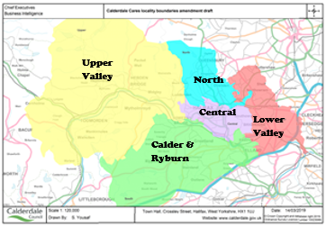
GPs in Calder & Ryburn
Bankfield Surgery
Brig Royd Surgery
Stainland Road Surgery
Station Road Surgery
Wards in Calder & Ryburn: The wards do not map exactly to the neighbourhood boundaries; however, the following wards have part of their population living within Calder & Ryburn; Elland 87%, Greetland and Stainland 92%, Ryburn 91%, Sowerby Bridge 57%

Population Characteristics
The total registered population of Calder & Ryburn is 42260, according to the 2022 GP Practice Populations.
There is a relatively small ethnic minority population at around (6.2%). The largest groups are Asian and Mixed or multiple ethnic groups accounting for 2.2% and 1.6% of the population respectively. According to the school census around 3.4% of primary and 2.6% of secondary school children are Asian.
Around 45.7% of the population are Christian, with only very small proportions having other religions.

Figure 1 Population Pyramid
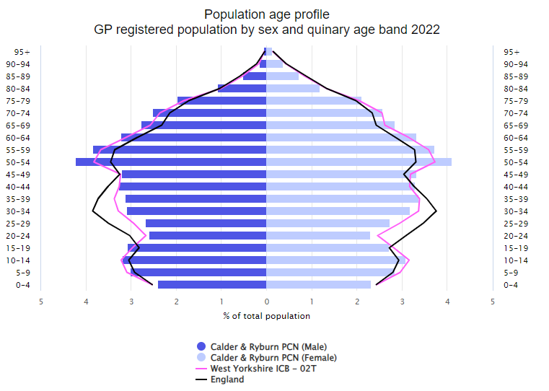
Source: GP Practice Populations 2022
The population pyramid shows that Calder and Ryburn has a lower proportion of 20- to 39-year-olds compared to Calderdale (Pink line – West Yorkshire ICB – 02T) and a higher proportion of 50 to 79 year olds compared to Calderdale.
Wider determinants of Health
Calder & Ryburn is one of the less deprived localities with lower levels of those claiming council tax reduction or Universal Credit. There are also lower levels of secondary school age children eligible for free school meals compared to the whole of Calderdale. However, this still represents just over 1 in 5 children at secondary age and 1 in 4 at primary age who are eligible for free school meals.
Just under 1 in 5 households have no car or van.

Starting well
The fertility rate is significantly lower than average, with around 410 babies being born in Calder & Ryburn each year.
The proportion of women still smoking at the time of delivery is lower than the Calderdale average with 1 in 12 still smoking.
The percentage of babies born with a low birth weight (less than 2500g) is significantly lower than for Calderdale. Approx. 22 babies in Calder & Ryburn are born with a low birth weight each year.
64.8% of mothers breastfeed following delivery, this is 64.2% when mother and baby are discharged from hospital but drops to 54.2% between 6 and 8 weeks post birth. These rates are similar to the Calderdale average.
Infant mortality rates are similar to the Calderdale average.
Developing Well
There are just under 1 in 6 children with excess weight in reception year and this increases to 1 in 3 children in year 6. These are both lower than the Calderdale average, but not significantly.
We do not have much information around the health conditions that children are living with, but we do know that the proportion claiming disability living allowance who are aged under 16 is significantly lower than the Calderdale average at 4.0%, compared to 4.7%.
Referrals to children’s social care are lower than the Calderdale average and around 5 per 1000 children are on a child protection plan which is similar to the Calderdale average.
Living and Working Well
Smoking rates are significantly lower compared to Calderdale overall, however around 15.4% of Calder & Ryburn residents are estimated to be smokers. Around 1 in 10 are obese which is significantly higher than the Calderdale average.
Life Expectancy
Males and females in Calder & Ryburn are expected to live to a similar age as the Calderdale average.
Long term conditions
According to the 2021 Census around 1 in 6 had a long-term health problem or disability which limits activities – this is significantly lower than the Calderdale average. We do not know how many of these had more than one long term condition. Around 83% stated they were in good or very good health which is significantly higher than the Calderdale average.
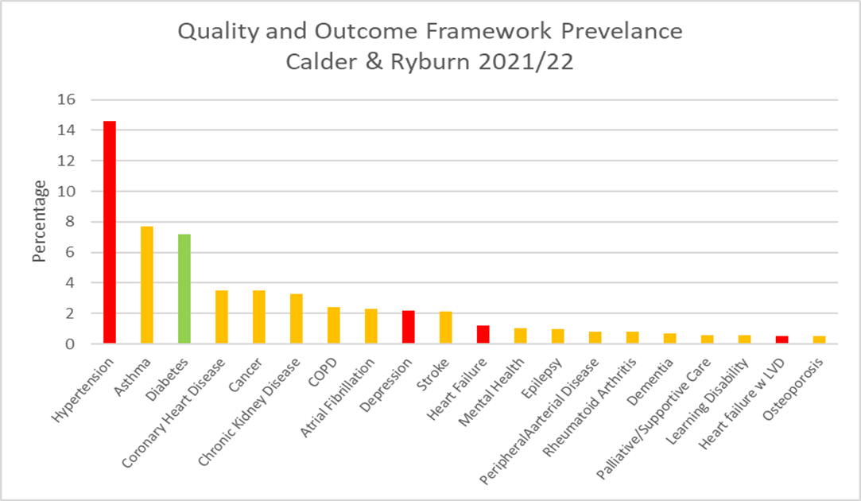
The graph above shows the percentage with each condition according to the Quality and Outcomes Framework (QOF). Bars coloured red are significantly higher than Calderdale, green is significantly lower, and amber is not significantly different. There are a few things to consider when interpreting this data:
- These rates do not take into account the age structure of the population so areas with a higher percentage of older people, like Calder and Ryburn are likely to have higher rates than the Calderdale average.
- Patients may have conditions that have not yet been diagnosed and therefore will not be included in the figures
- A high death rate will result in a lower prevalence
- There may be differences in coding and data quality that affect the figures
As can be seen from the graph, hypertension has the highest prevalence, followed by asthma and diabetes. However, we currently do not know how much clinical time is spent managing these conditions, the amount of medication used, and the costs associated with this. It could be that other conditions with a lower prevalence actually take up more clinical time and are more costly to manage.
It is useful to consider the incidence/prevalence of a condition as well as mortality rates, to get a better picture of need. However, it is important to bear in mind that the deaths have been adjusted to take into account the age structure of the population whereas the other data has not. Available data that we have for each condition is summarised below:
Circulatory Diseases
The percentage living with coronary heart disease, stroke and peripheral arterial disease are similar to the Calderdale average; however, hypertension and heart failure is significantly higher. Deaths from ischaemic heart disease are similar to Calderdale and deaths from cerebrovascular disease and cardiovascular disease (for 65 and under) are significantly lower than Calderdale.
Cancer
The screening rates for cervical and bowel cancer are better than the Calderdale average, though with just over 1 in 6 not attending cervical screening and around 1 in 4 not attending bowel cancer screening there is still scope to increase this. Calder & Ryburn is significantly worse for breast cancer screening, with around 3 in 5 people not attending.
The percentage with any type of cancer is similar to the Calderdale average. The emergency admission rate, percentage receiving palliative care and death rates are also similar to the Calderdale average.
Mental Health
The percentage recorded as having depression each year is higher than the Calderdale average with around 738 new diagnoses in 2021/22. Patients are only recorded as having depression if they receive medication, so if those not taking medication were included the numbers could be higher. The proportion living with mental health (schizophrenia, bipolar affective disorder, and other psychoses) is similar to the Calderdale average. Deaths from suicide are not significantly different to the Calderdale average.
Respiratory Conditions
Calder & Ryburn appears to have similar proportions living with COPD or asthma when compared to Calderdale overall. Deaths from respiratory conditions are also similar to Calderdale overall, apart from under 65s which is significantly lower.
What do people die from?
On average, around 367 of Calder & Ryburn ’s residents die each year. Around 106 people die per year from cancer, 89 cardiovascular diseases, 40 from ischaemic heart disease, 44 from respiratory conditions and 19 from cerebrovascular disease.

Figure 2 Directly Standardised Mortality Rates for Leading Causes of Death 2017-2021
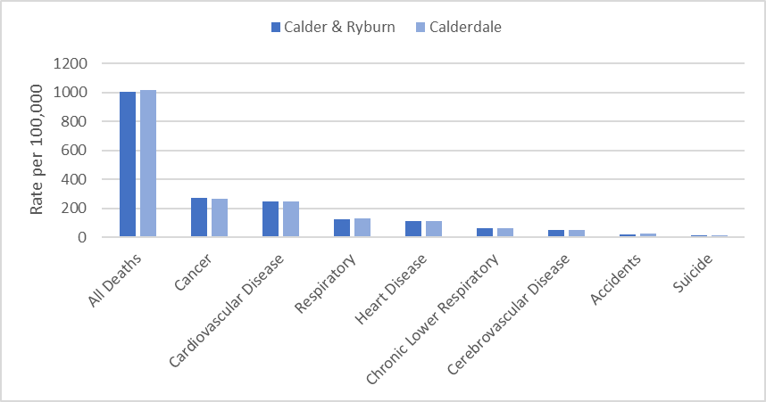
The directly standardised mortality rate (DSR) takes into account the age structure of the population and shows if the number of deaths per population is higher or lower compared to area averages.
Calder & Ryburn had similar rates to Calderdale for all listed causes of deaths for all ages, with no statistically significant differences.
Deaths from respiratory disease and cerebrovascular disease (aged less than 65) were significantly lower than Calderdale.
Premature mortality from cardiovascular disease for age groups under 65 and under 75 were also significantly lower than Calderdale
Ageing Well
Pension credit is extra money given to those who are over state pension age and on a low income, to help with living costs. There is a significantly lower proportion of those aged 65+ claiming pension credits compared to Calderdale overall.
Personal independence payment (PIP) is given to those with a long-term physical or mental health condition or disability who have difficulty doing certain everyday tasks or getting around. Attendance Allowance helps with extra costs if a person has a disability severe enough that they need someone to help look after them. Around 1 in 13 people aged 60+ claim PIP and around 1 in 10 aged 65+ claim attendance allowance. Both these figures are significantly lower than the Calderdale average.
Mortality in those aged 65 and over is either similar or slightly lower than Calderdale average, with no significant differences.

Public Health CMBC, September 2023, v2

Red is significantly worse than Calderdale  Green is significantly better than Calderdale  Blue is significantly different to Calderdale  Calderdale rated compared to England average  INDICATOR | Calder & Ryburn | Calderdale | England | Source
Population Characteristics
Population
Total registered population | 42260 | 213519 |  | GP Practice Populations 2022
Registered population 0-4 | 2006 | 10604 |  | GP Practice Populations 2022
Registered population 5-14 | 5162 | 26441 |  | GP Practice Populations 2022
Registered population 0-19 | 9630 | 49414 |  | GP Practice Populations 2022
Registered population aged 65 and over | 8070 | 40039 |  | GP Practice Populations 2022
Registered population aged 75 and over | 3511 | 18128 |  | GP Practice Populations 2022
Registered population aged 85 and over | 813 | 4672 |  | GP Practice Populations 2022
Ethnicity
Percentage of the population who are Irish | 0.7 | 0.8 | 0.9 | 2021 census
Percentage of the population who are Gypsy/Irish Travellers/Roma | 0.1 | 0.2 | 0.1 | 2021 census
Percentage of the population who are White Other | 1.6 | 2.4 | 6.4 | 2021 census
Percentage of the population who are Asian | 2.2 | 10.5 | 9.6 | 2021 census
Percentage of the population who are Black | 0.5 | 0.7 | 4.2 | 2021 census
Percentage of the population who are Mixed Race | 1.6 | 2.0 | 3.0 | 2021 census
Percentage of the population who are "other" | 0.3 | 0.7 | 2.2 | 2021 census
Percentage of primary school children attending Calderdale schools who are Asian | 3.4 | 17.8 | 12.8 | Jan 2023 School Census
Percentage of secondary school children attending Calderdale schools who are Asian | 2.6 | 17.7 | 12.9 | Jan 2023 School Census
Religion
Percentage of the population who are Christian | 45.7 | 41.5 | 46.3 | 2021 census
Percentage of the population who are Buddhist | 0.2 | 0.3 | 0.5 | 2021 census
Percentage of the population who are Hindu | 0.2 | 0.6 | 1.8 | 2021 census
Percentage of the population who are Jewish | 0.1 | 0.1 | 0.5 | 2021 census
Percentage of the population who are Muslim | 1.7 | 9.5 | 6.7 | 2021 census
Percentage of the population who are Sikh | 0.1 | 0.2 | 0.9 | 2021 census
Language
Percentage main language is not English and cannot speak English well or at all | 0.3 | 1.4 | 1.8 | 2021 census
Sexual Orientation
Percentage of 16+ residents who identify as LGBTQ+ | 2.8 | 3.2 | 3.2 | 2021 census
Wider determinants of health
Percentage of households claiming council tax reduction | 14.1 | 16.8 |  | Calderdale Council Tax system c/o Calderdale Council Qlikview, accessed April 2023
Percentage of households claiming housing benefit | 7.2 | 7.8 | 8.8 | DWP - Housing Benefit claimants February 2023; stat-xplore.dwp.gov.uk, accessed 30 May 2023; Census 2021 Number of households by LSOA
Percentage of households claiming universal credit | 17.0 | 20.9 | 16.6 | DWP - Households claiming universal credit February 2023; stat-xplore.dwp.gov.uk, accessed 31 May 2023; Census 2021 Number of households by LSOA
Percentage of primary school children eligible for free school meals | 24.8 | 26.8 | 24.0 | Jan 2023 School Census
Percentage of secondary school children eligible for free school meals | 22.7 | 26.1 | 22.7 | Jan 2023 School Census
Percentage of households that are owned outright | 33.2 | 34.6 | 32.5 | 2021 census
Percentage of households that are owner occupied - Mortgage/Loan | 32.8 | 30.4 | 29.8 | 2021 census
Percentage of households rented from a social landlord | 13.9 | 14.5 | 17.1 | 2021 census
Percentage of households rented privately | 19.9 | 20.4 | 20.5 | 2021 census
Percentage of households without central heating | 1.9 | 2.1 | 1.5 | 2021 census
Percentage of households with no car or van | 20.3 | 24.5 | 23.5 | 2021 Census
Starting Well
Fertility rate per 1000 women aged 15-44 [2017-2021] | 56.1 | 60.1 | 59.2 | ONS, calculated by CMBC
Live birth rate per 1000 women aged 15-44 [2017-2021] | 56.0 | 59.9 |  | ONS, calculated by CMBC
Still birth rate per 1000 births [2017-2021] | 2.0 | 3.8 |  | ONS, calculated by CMBC
Percentage of low birth weight babies [2017-2021] | 5.4 | 7.0 | 6.8 | ONS, calculated by CMBC, figure differ from national as includes all gestations
Infant mortality rate per 1000 live births [2017-2021] | 2.5 | 4.3 | 3.9 | ONS, calculated by CMBC
Percentage smoking at delivery (2022/23) | 8.4 | 10.0 |  | Maternity system, calculated by CMBC
Percentage breastfeeding at delivery (2022/23) | 64.8 | 60.3 | 71.7 | Maternity system, calculated by CMBC
Percentage breastfeeding at discharge (2022/23) | 64.2 | 59.4 |  | Maternity system, calculated by CMBC
Percentage breastfeeding at 6-8 weeks (2022/23) | 54.2 | 51.6 | 49.2 | Maternity system, calculated by CMBC
Percentage of households with dependent children | 28.2 | 28.3 | 28.4 | 2021 Census
Developing well
Percentage of those aged under 18 claiming disability living allowance (November 2022) | 4.0 | 4.7 | 4.8 | Stat-xplore DWP, GP practice populations 2022
Excess weight reception age children [2019/22] | 16.9 | 17.4 | 22.6 | NCMP
Excess weight year 6 children [2019/22] | 32.3 | 34.3 | 35.8 | NCMP
Rate per 1000 population aged 0 to 17 referred to children's social care (2023) | 49.7 | 55.4 |  | CMBC Cass system accessed 30 May 2023; Census 2021
Children on a child protection plan (rate per 1000) 31 March 2023 | 5.3 | 5.1 |  | CMBC Cass system accessed 30 May 2023; Census 2021
Living and working well
Estimated smoking prevalence QOF (15+) [2021/22] | 15.4 | 17.5 | 15.4 | QOF
Obesity QOF Prevalence (18+) Patients with a BMI of 30 or above (2021/22) | 10.4 | 9.4 | 9.7 | QOF
Life Expectancy and All Cause Mortality
Life expectancy at birth in males [2019-2021] | 79.0 | 78.2 | 79.4 | ONS, calculated by CMBC
Life expectancy at birth in females [2019-2021] | 82.9 | 82.4 | 83.1 | ONS, calculated by CMBC
Directly Standardised Death Rate all causes (all ages) [2017 -2021] | 1004.4 | 1017.9 |  | ONS, calculated by CMBC
Directly Standardised Death Rate all causes (aged <65) [2019 -2021] | 155.8 | 191.6 |  | ONS, calculated by CMBC
Long term conditions
Percentage of population with a long term health problem or disability which limits activities | 17.2 | 18.3 | 17.3 | 2021 census
Percentage of population who stated they were in good or very good health | 82.6 | 80.8 | 82.2 | 2021 census
Rate per 1000 population aged 18+ referred to adults social care (2021/22) | 44.2 | 47.7 |  | CMBC
Circulatory Diseases
Coronary Heart Disease prevalence (all ages) [2021/22] | 3.5 | 3.5 | 3.0 | QOF
Heart Failure: QOF prevalence (all ages) [2021/22] | 1.2 | 0.9 | 1.0 | QOF
Heart failure w LVD prevalence (all ages) [2021/22] | 0.5 | 0.3 | 0.4 | QOF
Stroke prevalence (all ages) [2021/22] | 2.1 | 2.0 | 1.8 | QOF
Atrial fibrillation: QOF prevalence (all ages) (2021/22) | 2.3 | 2.1 | 2.1 | QOF
Peripheral arterial disease QOF prevalence (all ages) [2021/22] | 0.8 | 0.8 | 0.6 | QOF
Hypertension: QOF prevalence (all ages) [2021/22] | 14.6 | 13.9 | 14.0 | QOF
DSR Deaths for ischaemic heart disease (all ages) [2017 -2021] | 110.7 | 110.7 |  | ONS, calculated by CMBC
DSR Deaths for ischaemic heart disease (aged <65) [2017 -2021] | 13.4 | 20.0 |  | ONS, calculated by CMBC
DSR Deaths for cerebrovascular disease (all ages) [2017 -2021] | 53.7 | 53.9 |  | ONS, calculated by CMBC
DSR Deaths for cerebrovascular disease (aged <65) [2017 -2021] | 3.4 | 6.4 |  | ONS, calculated by CMBC
DSR Deaths for cardiovascular disease (all ages) [2017 -2021] | 247.0 | 249.3 |  | ONS, calculated by CMBC
DSR Deaths for cardiovascular disease (aged <65) [2017 -2021] | 23.1 | 38.7 |  | ONS, calculated by CMBC
Cancer
Cancer prevalence all ages [2021/22] | 3.5 | 3.5 | 3.3 | QOF
Persons eligible, 25-49, attending cervical screening within target period (3.5 year coverage, %) 2021/22 | 82.3 | 71.7 | 69.0 | QOF
Persons eligible, 50-64, attending cervical screening within target period (5.5 year coverage, %) 2021/22 | 83.0 | 76.9 | 76.1 | QOF
Persons eligible, 50-70, screened for breast cancer in last 36 months (3 year coverage, %) 2021/22 | 41.2 | 47.2 | 62.3 | QOF
Persons eligible, 60-74, screened for bowel cancer in last 30 months (2.5 year coverage, %) 2021/22 | 75.9 | 72.8 | 70.3 | QOF
Number of emergency admissions with cancer (per 100,000) [2021/22] | 485.0 | 475.0 | 514.0 | QOF
Palliative/supportive care: QOF prevalence (all ages) [2021/22] | 0.6 | 0.5 | 0.5 | QOF
DSR for cancer (all ages) [2017 -2021] | 271.7 | 263.6 |  | ONS, calculated by CMBC
DSR for cancer (aged <65) [2017 -2021] | 55.5 | 58.9 |  | ONS, calculated by CMBC
Mental Health
Mental Health: QOF prevalence (all ages) [2021/22] | 1.0 | 1.1 | 1.0 | QOF
Depression: QOF incidence (18+) - new diagnosis [2021/22] | 2.2 | 1.8 | 1.5 | QOF
Dementia: QOF prevalence (all ages) [2021/22] | 0.7 | 0.7 | 0.7 | QOF
DSR for suicide (all ages) [2017-2021] | 14.0 | 13.5 |  | ONS, calculated by CMBC
Respiratory Conditions
COPD: QOF prevalence (all ages) [2021/22] | 2.4 | 2.2 | 1.9 | QOF
Asthma: QOF prevalence (all ages (6+)) [2021/22] | 7.7 | 7.4 | 6.5 | QOF
DSR for respiratory conditions (all ages) [2017-2021] | 122.8 | 132.3 |  | ONS, calculated by CMBC
DSR for respiratory conditions (aged <65) [2017-2021] | 9.7 | 15.6 |  | ONS, calculated by CMBC
DSR for chronic lower respiratory conditions (all ages) [2017-2021] | 60.7 | 62.0 |  | ONS, calculated by CMBC
DSR for chronic lower respiratory conditions (aged <65) [2017-2021] | 5.4 | 8.0 |  | ONS, calculated by CMBC
Other
Learning disability: QOF prevalence [2021/22] | 0.6 | 0.7 | 0.5 | QOF
Chronic Kidney Disease: QOF prevalence (18+) [2021/22] | 3.3 | 3.6 | 4.0 | QOF
Diabetes: QOF prevalence (17+) [2021/22] | 7.2 | 7.8 | 7.3 | QOF
Epilepsy: QOF prevalence (18+) [2021/22] | 1.0 | 1.0 | 0.8 | QOF
Rheumatoid Arthritis: QOF prevalence (16+) [2021/22] | 0.8 | 0.8 | 0.8 | QOF
DSR for accidents (all ages) [2017-2021] | 20.6 | 25.7 |  | ONS, calculated by CMBC
DSR for accidents (aged <65) [2017-2021] | 12.5 | 16.4 |  | ONS, calculated by CMBC
Ageing Well
Percentage aged 60+ claiming Personal Independence Payment (Jan 2023) | 7.6 | 8.5 | 6.5 | Stat-xplore DWP, GP practice populations 2022
Percentage aged 65+ claiming Attendance Allowance (Jan 2023) | 10.4 | 11.4 | 12.0 | Stat-xplore DWP, GP practice populations 2022
Percentage aged 65+ claiming pension credit (Nov 2022) | 9.5 | 11.0 | 11.2 | Stat-xplore DWP, GP practice populations 2022
Osteoporosis: QOF prevalence (50+) [2021/22] | 0.5 | 0.6 | 0.8 | QOF
DSR Deaths for all causes (aged 65+) [2017-2021] | 4507.8 | 4429.2 |  | ONS, calculated by CMBC
DSR Deaths for accidents (aged 65+) [2017-2021] | 53.7 | 64.2 |  | ONS, calculated by CMBC
DSR Deaths from Dementia (aged 65+) [2017-2021] | 315.2 | 305.2 |  | ONS, calculated by CMBC
DSR Deaths for ischaemic heart disease (aged 65+) [2017-2021] | 512.6 | 485.1 |  | ONS, calculated by CMBC
DSR Deaths from cerebrovascular disease (aged 65+) [2017-2021] | 261.6 | 249.9 |  | ONS, calculated by CMBC
DSR Deaths from cardiovascular disease (aged 65+) [2017-2021] | 1171.5 | 1118.4 |  | ONS, calculated by CMBC
DSR Deaths for cancer (aged 65+) [2017-2021] | 1164.2 | 1108.7 |  | ONS, calculated by CMBC
DSR Deaths for respiratory disease (aged 65+) [2017-2021] | 589.9 | 613.6 |  | ONS, calculated by CMBC
DSR Deaths for chronic lower respiratory disease (aged 65+) [2017-2021] | 288.9 | 284.7 |  | ONS, calculated by CMBC

Please contact the Public Health Intelligence team at ph.intelligence@calderdale.gov.uk if you require this data in another format.

