Calderdale Cares Neighbourhood Profile – North Halifax
Map of area
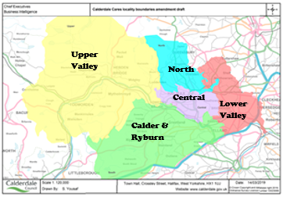
GPs in North
Beechwood Medical Practice
Caritas Group Practice – 3 Practices
Keighley Road Surgery
Plane Trees Group Practice
Wards in North Neighbourhood: The wards do not map exactly to neighbourhood boundaries, however the following wards have part of their population living within North; Illingworth and Mixenden 86%, Ovenden 80%, Town 44%, Warley 42% and Northowram & Shelf 34%.

Population Characteristics
The total registered population of North is 37,686, according to the 2022 GP Practice Populations.
There is a relatively small ethnic minority population (10.0%) with “White other” being the most sizeable, accounting for 3.4% of the population followed by 3.2% being Asian. According to the school census around 4.0% of secondary school children and 4.7% of primary school children are Asian.
Just over two fifths of the population are Christian, with only very small proportions having other religions.
Figure 1 Population Pyramid
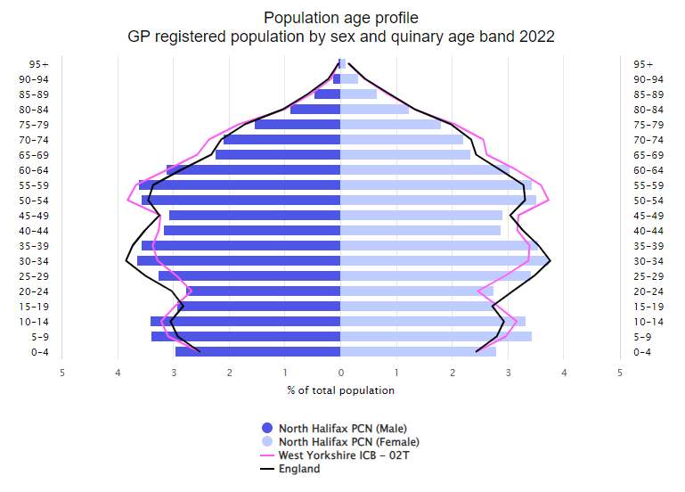
Source: GP Practice Populations 2022
The population pyramid shows that North has a higher proportion of those aged 0-4, 5- 14 and 25-39 compared to Calderdale (Pink line – West Yorkshire ICB – 02T). There are lower proportions aged 40 – 49 and 65-74 compared to Calderdale.
Wider determinants of Health
North is a relatively deprived neighbourhood with 1 in 4 of its households claiming a council tax reduction, around 1 in 9 claiming housing benefit and 1 in 3 claiming universal credit; all are significantly higher than the Calderdale rate. Over a third of primary and secondary school children are eligible for free school meals. Both these figures are significantly higher than the Calderdale average.
24.3% of households rent from a social landlord and 20.1% rent privately, which is significantly higher than the Calderdale average.
Around a third of households do not have access to a car or van, which is significantly higher than the Calderdale average.

Starting Well
The fertility rate is higher than the Calderdale average, with around 460 babies being born each year.
Around 1 in 7 mothers are still smoking at the time of delivery - significantly more than the Calderdale average.
The percentage of babies born with a low birth weight (less than 2500g) is significantly higher than for Calderdale. Approx. 39 babies in North are born with a low birth weight each year.
49.9% of mothers breastfeed following delivery, this drops to 47.8% by the time mother and baby are discharged from hospital and 39.9% between 6- and 8-weeks post birth. These rates are all significantly lower than the Calderdale average.
Developing Well
Just under 1 in 3 households in North have dependent children, which is similar to the Calderdale average.
Just under 19% of reception age children have excess weight and by year 6 this has increased to around 37% which is significantly higher than the Calderdale average.
We do not have much information around the health conditions that children are living with, but we do know that the proportion claiming disability living allowance who are aged under 16 is the highest of the neighbourhoods at 7.3% and is significantly higher than Calderdale.
The referral rate to children’s social care in North is the highest of the neighbourhoods at 84.9 per 1000 children and this is significantly higher than the Calderdale average. 9.8 per 1000 children are on a child protection plan which is also significantly higher.
Living and working well
The smoking rate is significantly higher than the Calderdale average with figures from the Quality and Outcomes Framework (QOF) estimating that 1 in 4 smoke.
There is also a higher prevalence of those aged 18 and over with a body mass index of 30 or above (12.4%)
We do not have any other information around healthy lifestyles in adults in this area.
Life Expectancy
Both males and females in North are expected to live over three years less than the Calderdale average and these differences are statistically significant.

Long term conditions
According to the 2021 Census, around 1 in 5 had a long-term health problem or disability which limits activities – this is significantly higher than the Calderdale average. We do not know how many of these had more than one long term condition.
There are around 52 people aged 18 or over per 1000 population referred to adult’s social care each year, this is significantly higher than the Calderdale average.
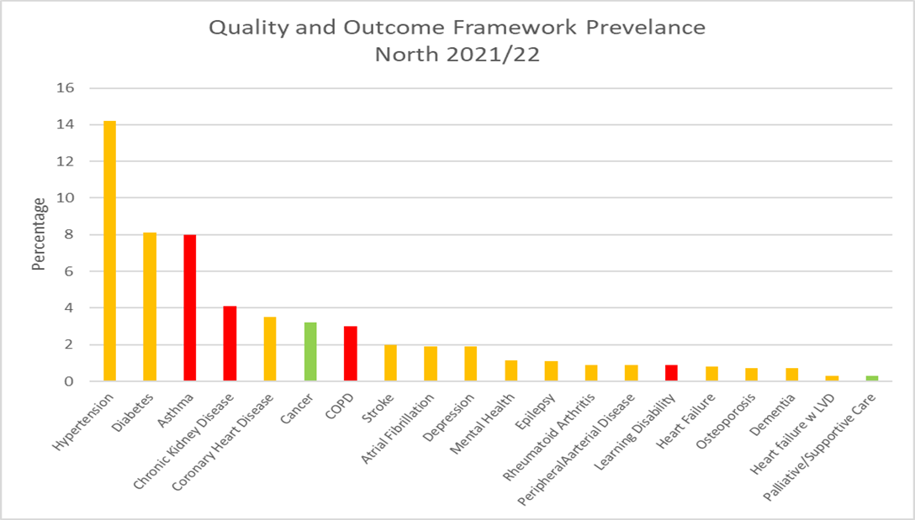
The graph above shows the percentage with each condition according to the Quality and Outcomes Framework (QOF) register. Bars coloured red are significantly higher than Calderdale, green is significantly lower and amber is not significantly different. There are a few things to consider when interpreting this data:
- These rates do not take into account the age structure of the population so areas with a high percentage of older people are likely to have higher rates than the Calderdale average.
- Patients may have conditions that have not yet been diagnosed and therefore will not be included in the figures
- A high death rate will result in a lower prevalence
- There may be differences in coding and data quality that affect the figures
As can be seen from the graph, hypertension has the highest prevalence, followed by diabetes and asthma. However, we currently do not know how much clinical time is spent managing these conditions, the amount of medication used and the costs associated with this. It could be that other conditions with a lower prevalence actually take up more clinical time and are more costly to manage.
It is useful to consider the incidence/prevalence of a condition as well as mortality rates, to get a better picture of need. However, it is important to bear in mind that the deaths have been adjusted to take into account the age structure of the population whereas the other data has not. Available data that we have for each condition is summarised below;
Circulatory Diseases
The percentage living with coronary heart disease and hypertension is similar to the Calderdale average. Deaths from ischemic heart disease are significantly higher than Calderdale average across all ages.
The percentage with a diagnosis of heart failure (both with and without left ventricular dysfunction) and stroke are both similar to the Calderdale average, but deaths from cardiovascular disease is significantly higher than Calderdale average across all ages.
Cancer
Screening figures for cervical cancer in 50-64 year olds, breast cancer and bowel cancer are all significantly lower/worse than the Calderdale average. The percentage with any type of cancer is significantly lower than the Calderdale average and the percentage receiving palliative/supportive care is also lower. The mortality rate for cancer is not significantly different to the overall Calderdale rate.
Mental health
The percentage diagnosed with depression each year is similar to the Calderdale average. Patients are only recorded as having depression if they receive medication, so if those not taking medication were included the numbers could be higher. The proportion living with mental health (schizophrenia, bipolar affective disorder and other psychoses) is also similar to the Calderdale average.
The death rate from suicide is not significantly different to the Calderdale average.
Respiratory conditions
Respiratory conditions are an issue for North with a significantly higher than average percentage living with chronic obstructive pulmonary disease (COPD) and Asthma. There is also significantly higher mortality from respiratory conditions, including chronic lower respiratory, compared to Calderdale.
Other
According to QOF, the 0.9% of the population in North have a learning disability and this is significantly higher than the Calderdale average.
Just over 4% have chronic kidney disease which is significantly higher than the Calderdale average.
What do people die from?
On average, around 398 of North’s residents die each year. Around 103 people die per year from cardiovascular disease, 102 from cancer, 56 from respiratory conditions, 50 from ischaemic heart disease, 19 from cerebrovascular disease and 7 residents die by suicide.
Figure 2 Standardised Mortality Ratios for Leading Causes of Death 2017-2021
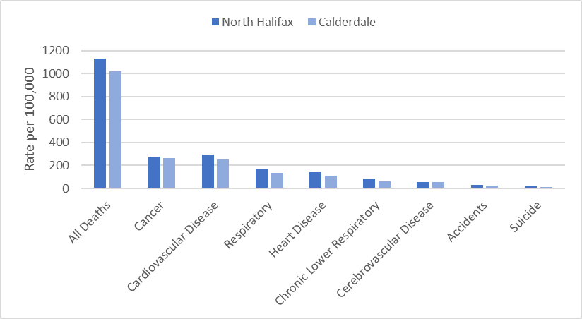
The directly standardised mortality rate (DSR) takes into account the age structure of the population and shows if the number of deaths per population is higher or lower compared to area averages.
The overall mortality rate in North was significantly higher than for Calderdale. The mortality rates from cardiovascular disease, ischaemic heart disease and respiratory conditions were significantly higher than the Calderdale average. In those aged 65 or less mortality rates were higher for cardiovascular disease and ischemic heart disease, compared to Calderdale.
Ageing well
Pension credit is extra money given to those who are over state pension age and on a low income, to help with living costs. Older people living in North appear to be relatively more deprived than the Calderdale average with significantly more people aged 65+ claiming pension credit. Just over 1 in 6 claims in North, compared to 1 in 9 in Calderdale overall.
Personal independence payment (PIP) is given to those with a long-term physical or mental health condition or disability who have difficulty doing certain everyday tasks or getting around. Attendance Allowance helps with extra costs if a person has a disability severe enough that they need someone to help look after them. The health of older people in North Halifax appears to be worse than the Calderdale average with significantly higher percentages claiming Personal Independence Payment (60+) (12.3%) and Attendance Allowance (65+) (13.6%).
Mortality from heart disease, respiratory conditions and cardiovascular disease in those aged 65 plus are all significantly higher than Calderdale average.

Public Health CMBC,
September 2023 V2

Red is significantly worse than Calderdale  Green is significantly better than Calderdale  Blue is significantly different to Calderdale  Calderdale rated compared to England average  INDICATOR | North | Calderdale | England | Source
Population Characteristics
Population
Total registered population | 37686 | 213519 |  | GP Practice Populations 2022
Registered population 0-4 | 2164 | 10604 |  | GP Practice Populations 2022
Registered population 5-14 | 5110 | 26441 |  | GP Practice Populations 2022
Registered population 0-19 | 9422 | 49414 |  | GP Practice Populations 2022
Registered population aged 65 and over | 6032 | 40039 |  | GP Practice Populations 2022
Registered population aged 75 and over | 2695 | 18128 |  | GP Practice Populations 2022
Registered population aged 85 and over | 639 | 4672 |  | GP Practice Populations 2022
Ethnicity
Percentage of the population who are Irish | 1.0 | 0.8 | 0.9 | 2021 census
Percentage of the population who are Gypsy/Irish Travellers/Roma | 0.1 | 0.2 | 0.1 | 2021 census
Percentage of the population who are White Other | 3.4 | 2.4 | 6.4 | 2021 census
Percentage of the population who are Asian | 3.2 | 10.5 | 9.6 | 2021 census
Percentage of the population who are Black | 0.8 | 0.7 | 4.2 | 2021 census
Percentage of the population who are Mixed Race | 2.1 | 2.0 | 3.0 | 2021 census
Percentage of the population who are "other" | 0.6 | 0.7 | 2.2 | 2021 census
Percentage of primary school children attending Calderdale schools who are Asian | 4.7 | 17.8 | 12.8 | Jan 2023 School Census
Percentage of secondary school children attending Calderdale schools who are Asian | 4.0 | 17.7 | 12.9 | Jan 2023 School Census
Religion
Percentage of the population who are Christian | 43.2 | 41.5 | 46.3 | 2021 census
Percentage of the population who are Buddhist | 0.2 | 0.3 | 0.5 | 2021 census
Percentage of the population who are Hindu | 0.2 | 0.6 | 1.8 | 2021 census
Percentage of the population who are Jewish | 0.1 | 0.1 | 0.5 | 2021 census
Percentage of the population who are Muslim | 2.7 | 9.5 | 6.7 | 2021 census
Percentage of the population who are Sikh | 0.1 | 0.2 | 0.9 | 2021 census
Language
Percentage main language is not English and cannot speak English well or at all | 0.9 | 1.4 | 1.8 | 2021 census
Sexual Orientation
Percentage of 16+ residents who identify as LGBTQ+ | 3.1 | 3.2 | 3.2 | 2021 census
Wider determinants of health
Percentage of households claiming council tax reduction | 24.0 | 16.8 |  | Calderdale Council Tax system c/o Calderdale Council Qlikview, accessed April 2023
Percentage of households claiming housing benefit | 11.1 | 7.8 | 8.8 | DWP - Housing Benefit claimants February 2023; stat-xplore.dwp.gov.uk, accessed 30 May 2023; Census 2021 Number of households by LSOA
Percentage of households claiming universal credit | 31.7 | 20.9 | 16.6 | DWP - Households claiming universal credit February 2023; stat-xplore.dwp.gov.uk, accessed 31 May 2023; Census 2021 Number of households by LSOA
Percentage of primary school children eligible for free school meals | 39.7 | 26.8 | 24.0 | Jan 2023 School Census
Percentage of secondary school children eligible for free school meals | 37.7 | 26.1 | 22.7 | Jan 2023 School Census
Percentage of households that are owned outright | 27.9 | 34.6 | 32.5 | 2021 census
Percentage of households that are owner occupied - Mortgage/Loan | 27.7 | 30.4 | 29.8 | 2021 census
Percentage of households rented from a social landlord | 24.3 | 14.5 | 17.1 | 2021 census
Percentage of households rented privately | 20.1 | 20.4 | 20.5 | 2021 census
Percentage of households without central heating | 2.1 | 2.1 | 1.5 | 2021 census
Percentage of households with no car or van | 31.9 | 24.5 | 23.5 | 2021 Census
Starting Well
Fertility rate per 1000 women aged 15-44 [2017-2021] | 66.9 | 60.1 | 59.2 | ONS, calculated by CMBC
Live birth rate per 1000 women aged 15-44 [2017-2021] | 66.6 | 59.9 |  | ONS, calculated by CMBC
Still birth rate per 1000 births [2017-2021] | 4.3 | 3.8 |  | ONS, calculated by CMBC
Percentage of low birth weight babies [2017-2021] | 8.6 | 7.0 | 6.8 | ONS, calculated by CMBC, figure differ from national as includes all gestations
Infant mortality rate per 1000 live births [2017-2021] | 7.9 | 4.3 | 3.9 | ONS, calculated by CMBC
Percentage smoking at delivery (2022/23) | 14.2 | 10.0 |  | Maternity system, calculated by CMBC
Percentage breastfeeding at delivery (2022/23) | 49.9 | 60.3 | 71.7 | Maternity system, calculated by CMBC
Percentage breastfeeding at discharge (2022/23) | 47.8 | 59.4 |  | Maternity system, calculated by CMBC
Percentage breastfeeding at 6-8 weeks (2022/23) | 39.9 | 51.6 | 49.2 | Maternity system, calculated by CMBC
Percentage of households with dependent children | 30.4 | 28.3 | 28.4 | 2021 Census
Developing well
Percentage of those aged under 18 claiming disability living allowance (November 2022) | 7.3 | 4.7 | 4.8 | Stat-xplore DWP, GP practice populations 2022
Excess weight reception age children [2019/22] | 18.7 | 17.4 | 22.6 | NCMP
Excess weight year 6 children [2019/22] | 36.9 | 34.3 | 35.8 | NCMP
Rate per 1000 population aged 0 to 17 referred to children's social care (2023) | 84.9 | 55.4 |  | CMBC Cass system accessed 30 May 2023; Census 2021
Children on a child protection plan (rate per 1000) 31 March 2023 | 9.8 | 5.1 |  | CMBC Cass system accessed 30 May 2023; Census 2021
Living and working well
Estimated smoking prevalence QOF (15+) [2021/22] | 24.1 | 17.5 | 15.4 | QOF
Obesity QOF Prevalence (18+) Patients with a BMI of 30 or above (2021/22) | 12.4 | 9.4 | 9.7 | QOF
Life Expectancy and All Cause Mortality
Life expectancy at birth in males [2019-2021] | 74.5 | 78.2 | 79.4 | ONS, calculated by CMBC
Life expectancy at birth in females [2019-2021] | 78.8 | 82.4 | 83.1 | ONS, calculated by CMBC
Directly Standardised Death Rate all causes (all ages) [2017 -2021] | 1132.1 | 1017.9 |  | ONS, calculated by CMBC
Directly Standardised Death Rate all causes (aged <65) [2019 -2021] | 236.4 | 191.6 |  | ONS, calculated by CMBC
Long term conditions
Percentage of population with a long term health problem or disability which limits activities | 21.1 | 18.3 | 17.3 | 2021 census
Percentage of population who stated they were in good or very good health | 77.9 | 80.8 | 82.2 | 2021 census
Rate per 1000 population aged 18+ referred to adults social care (2021/22) | 52.3 | 47.7 |  | CMBC
Circulatory Diseases
Coronary Heart Disease prevalence (all ages) [2021/22] | 3.5 | 3.5 | 3.0 | QOF
Heart Failure: QOF prevalence (all ages) [2021/22] | 0.8 | 0.9 | 1.0 | QOF
Heart failure w LVD prevalence (all ages) [2021/22] | 0.3 | 0.3 | 0.4 | QOF
Stroke prevalence (all ages) [2021/22] | 2.0 | 2.0 | 1.8 | QOF
Atrial fibrillation: QOF prevalence (all ages) (2021/22) | 1.9 | 2.1 | 2.1 | QOF
Peripheral arterial disease QOF prevalence (all ages) [2021/22] | 0.9 | 0.8 | 0.6 | QOF
Hypertension: QOF prevalence (all ages) [2021/22] | 14.2 | 13.9 | 14.0 | QOF
DSR Deaths for ischaemic heart disease (all ages) [2017 -2021] | 140.3 | 110.7 |  | ONS, calculated by CMBC
DSR Deaths for ischaemic heart disease (aged <65) [2017 -2021] | 28.9 | 20.0 |  | ONS, calculated by CMBC
DSR Deaths for cerebrovascular disease (all ages) [2017 -2021] | 57.1 | 53.9 |  | ONS, calculated by CMBC
DSR Deaths for cerebrovascular disease (aged <65) [2017 -2021] | 8.9 | 6.4 |  | ONS, calculated by CMBC
DSR Deaths for cardiovascular disease (all ages) [2017 -2021] | 294.6 | 249.3 |  | ONS, calculated by CMBC
DSR Deaths for cardiovascular disease (aged <65) [2017 -2021] | 56.2 | 38.7 |  | ONS, calculated by CMBC
Cancer
Cancer prevalence all ages [2021/22] | 3.2 | 3.5 | 3.3 | QOF
Persons eligible, 25-49, attending cervical screening within target period (3.5 year coverage, %) 2021/22 | 73.3 | 71.7 | 69.0 | QOF
Persons eligible, 50-64, attending cervical screening within target period (5.5 year coverage, %) 2021/22 | 73.4 | 76.9 | 76.1 | QOF
Persons eligible, 50-70, screened for breast cancer in last 36 months (3 year coverage, %) 2021/22 | 22.6 | 47.2 | 62.3 | QOF
Persons eligible, 60-74, screened for bowel cancer in last 30 months (2.5 year coverage, %) 2021/22 | 70.0 | 72.8 | 70.3 | QOF
Number of emergency admissions with cancer (per 100,000) [2021/22] | 398.0 | 475.0 | 514.0 | QOF
Palliative/supportive care: QOF prevalence (all ages) [2021/22] | 0.3 | 0.5 | 0.5 | QOF
DSR for cancer (all ages) [2017 -2021] | 278.1 | 263.6 |  | ONS, calculated by CMBC
DSR for cancer (aged <65) [2017 -2021] | 63.8 | 58.9 |  | ONS, calculated by CMBC
Mental Health
Mental Health: QOF prevalence (all ages) [2021/22] | 1.2 | 1.1 | 1.0 | QOF
Depression: QOF incidence (18+) - new diagnosis [2021/22] | 1.9 | 1.8 | 1.5 | QOF
Dementia: QOF prevalence (all ages) [2021/22] | 0.7 | 0.7 | 0.7 | QOF
DSR for suicide (all ages) [2017-2021] | 15.7 | 13.5 |  | ONS, calculated by CMBC
Respiratory Conditions
COPD: QOF prevalence (all ages) [2021/22] | 3.0 | 2.2 | 1.9 | QOF
Asthma: QOF prevalence (all ages (6+)) [2021/22] | 8.0 | 7.4 | 6.5 | QOF
DSR for respiratory conditions (all ages) [2017-2021] | 164.6 | 132.3 |  | ONS, calculated by CMBC
DSR for respiratory conditions (aged <65) [2017-2021] | 21.5 | 15.6 |  | ONS, calculated by CMBC
DSR for chronic lower respiratory conditions (all ages) [2017-2021] | 83.3 | 62.0 |  | ONS, calculated by CMBC
DSR for chronic lower respiratory conditions (aged <65) [2017-2021] | 12.1 | 8.0 |  | ONS, calculated by CMBC
Other
Learning disability: QOF prevalence [2021/22] | 0.9 | 0.7 | 0.5 | QOF
Chronic Kidney Disease: QOF prevalence (18+) [2021/22] | 4.1 | 3.6 | 4.0 | QOF
Diabetes: QOF prevalence (17+) [2021/22] | 8.1 | 7.8 | 7.3 | QOF
Epilepsy: QOF prevalence (18+) [2021/22] | 1.1 | 1.0 | 0.8 | QOF
Rheumatoid Arthritis: QOF prevalence (16+) [2021/22] | 0.9 | 0.8 | 0.8 | QOF
DSR for accidents (all ages) [2017-2021] | 28.2 | 25.7 |  | ONS, calculated by CMBC
DSR for accidents (aged <65) [2017-2021] | 20.5 | 16.4 |  | ONS, calculated by CMBC
Ageing Well
Percentage aged 60+ claiming Personal Independence Payment (Jan 2023) | 12.3 | 8.5 | 6.5 | Stat-xplore DWP, GP practice populations 2022
Percentage aged 65+ claiming Attendance Allowance (Jan 2023) | 13.6 | 11.4 | 12.0 | Stat-xplore DWP, GP practice populations 2022
Percentage aged 65+ claiming pension credit (Nov 2022) | 16.1 | 11.0 | 11.2 | Stat-xplore DWP, GP practice populations 2022
Osteoporosis: QOF prevalence (50+) [2021/22] | 0.7 | 0.6 | 0.8 | QOF
DSR Deaths for all causes (aged 65+) [2017-2021] | 4830.0 | 4429.2 |  | ONS, calculated by CMBC
DSR Deaths for accidents (aged 65+) [2017-2021] | 59.9 | 64.2 |  | ONS, calculated by CMBC
DSR Deaths from Dementia (aged 65+) [2017-2021] | 354.2 | 305.2 |  | ONS, calculated by CMBC
DSR Deaths for ischaemic heart disease (aged 65+) [2017-2021] | 600.2 | 485.1 |  | ONS, calculated by CMBC
DSR Deaths from cerebrovascular disease (aged 65+) [2017-2021] | 256.0 | 249.9 |  | ONS, calculated by CMBC
DSR Deaths from cardiovascular disease (aged 65+) [2017-2021] | 1279.0 | 1118.4 |  | ONS, calculated by CMBC
DSR Deaths for cancer (aged 65+) [2017-2021] | 1163.0 | 1108.7 |  | ONS, calculated by CMBC
DSR Deaths for respiratory disease (aged 65+) [2017-2021] | 755.3 | 613.6 |  | ONS, calculated by CMBC
DSR Deaths for chronic lower respiratory disease (aged 65+) [2017-2021] | 379.9 | 284.7 |  | ONS, calculated by CMBC

Please contact the Public Health Intelligence team at ph.intelligence@calderdale.gov.uk if you require this data in another format.

