Calderdale Cares Neighbourhood Profile – Upper
Map of Area
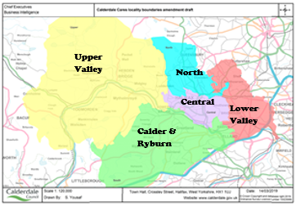
GPs in Upper
Calder Community Practice
Hebden Bridge Group Practice
Todmorden Health Centre
Wards in the Upper: The wards do not map to the neighbourhood boundaries, however the following wards have part of their population living within Upper; Calder 96%, Luddendenfoot 89%, Todmorden 82%.

Population Characteristics
The total registered population of Upper is 34,791, according to 2022 GP Practice population.
There is a relatively small ethnic minority population (7.6%) with White other and Asian being the largest groups, accounting for 2.5% and 2.3% of the population respectively. Around 3.7% of primary and 3.2% of secondary school pupils are Asian.
Around 6.3% of the 16+ population identifies as LGBTQ+ and this is significantly higher than the Calderdale average of 3.2%.

Figure 1 Population Pyramid
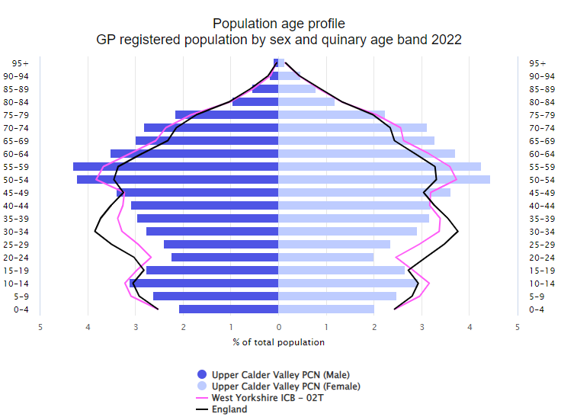
Source: GP Practice Populations 2022
The population pyramid shows that Upper has a higher proportion of those aged 50 to 79 compared to Calderdale (Pink line – West Yorkshire ICB – 02T) and a lower proportion of 0 to 9 year olds and 20 to 44 year olds.
Wider determinants of Health
Upper is one of the less deprived areas with significantly lower levels of those claiming council tax reduction and universal credit and lower levels claiming housing benefit. There are also significantly lower levels of primary and secondary school age children eligible for free school meals compared to the whole of Calderdale.
Around 1 in 4 households have no car or van.
Starting Well
The fertility rate is lower than the Calderdale average, with around 295 babies being born each year.
The proportion of women still smoking at the time of delivery, the percentage breastfeeding and the percentage of babies born with a low birth weight are not significantly different to the Calderdale average.
However around 1 in 15 are still smoking at the time of delivery and around 17 babies are born with a low birth weight each year.
62.3% of mothers breastfeed following delivery, this drops slightly to 61.9% by the time mother and baby are discharged from hospital and 58.3% between 6- and 8-weeks post birth.
Developing Well
Around 1 in 4 households in Upper have dependent children.
Excess weight for reception age children is lower than the Calderdale average, but not significantly. By year 6 it is significantly lower than the Calderdale average, but still an issue with just over 1 in 4 children having excess weight.
We do not have much information around the health conditions that children are living with, but we do know that the proportion claiming disability living allowance is lower than Calderdale at 3.9%.
The referral rate to children’s social care and those on a child protection plan was significantly lower than for Calderdale.
Living and Working Well
Smoking rates are significantly lower when compared to Calderdale overall, however around 16.7% of Upper residents are estimated to be smokers, so this is still an issue.
We currently do not have any other information around healthy lifestyles in adults at neighbourhood level; however, the QOF for 18+ year olds with a BMI 30 or over is significantly lower than Calderdale.
Life Expectancy
Males and females in Upper are expected to live almost two years longer than the Calderdale average and this is significantly higher.
Long term conditions
According to the 2021 Census, 19.4% stated they have a long-term health problem or disability which limits activities – this is significantly higher than the Calderdale average. We do not know how many of these had more than one long term condition.
Referrals to adult’s social care were significantly lower than the Calderdale average.
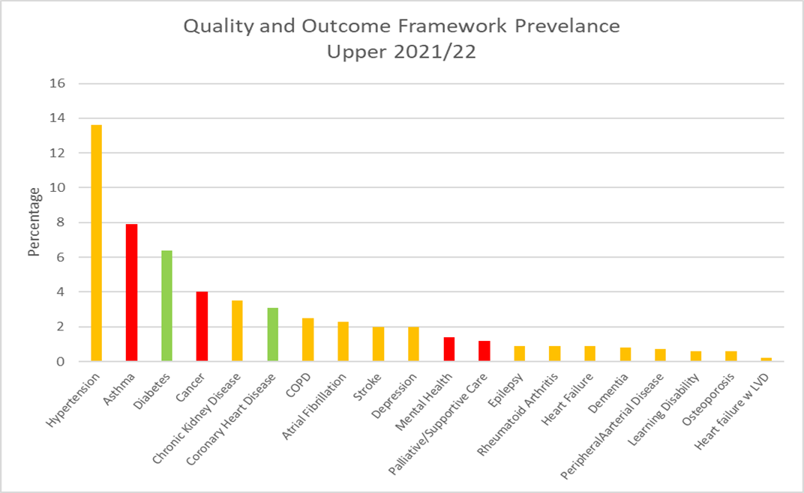
The graph above shows the percentage with each condition according to the Quality and Outcomes Framework (QOF) register. Bars coloured red are significantly higher than Calderdale, green is significantly lower and amber is not significantly different. There are a few things to consider when interpreting this data:
- These rates do not take into account the age structure of the population so areas with a higher percentage of older people, like we have in Upper, are likely to have higher rates than the Calderdale average.
- Patients may have conditions that have not yet been diagnosed and therefore will not be included in the figures
- A high death rate will result in a lower prevalence
- There may be differences in coding and data quality that affect the figures
As can be seen from the graph, hypertension has the highest prevalence, followed by asthma, which is significantly higher than the Calderdale average, then diabetes which is significantly better than Calderdale. We currently do not know how much clinical time is spent managing these conditions, the amount of medication used and the costs associated with this. It could be that other conditions with a lower prevalence actually take up more clinical time and are more costly to manage.
It is useful to consider the incidence/prevalence of a condition as well as mortality rates, to get a better picture of need. However, it is important to bear in mind that the deaths have been adjusted to take into account the age structure of the population whereas the other data has not. Available data that we have for each condition is summarised on the next page:
Circulatory Diseases
The proportion with chronic heart disease is significantly lower than for Calderdale; with heart failure with left ventricular dysfunction and hypertension being less than the Calderdale average, but not significantly. Deaths from ischaemic heart disease in Upper compared to Calderdale, are significantly lower for under 65s and all ages.
Cancer
The screening rate for breast cancer is significantly lower than the Calderdale average with just over 1 in 3 attending screening. Screening for bowel cancer is similar to the Calderdale average although with just under 1 in 3 not attending screening there is scope to increase this. The percentage attending cervical screening is significantly higher for ages 25-49, but significantly lower for ages 50-64, with around 1 in 4 not being screened for both age ranges.

The percentage diagnosed with any form of cancer for 2021/22 was significantly higher than the Calderdale average, this is also the same for the proportion of those receiving palliative support/care for Cancer. The death rate from cancer is not significantly different to the Calderdale rate.
Mental Health
The proportion of people living with mental health (schizophrenia, bipolar affective disorder and other psychoses) is significantly higher than the Calderdale average. However, the percentage diagnosed with depression each year is similar to the Calderdale average; patients are only recorded as having depression if they receive medication, so if those not taking medication were included the numbers could be higher.
The mortality rate from suicide is not significantly different to Calderdale.
Respiratory Conditions
The percentage of those with asthma is significantly higher than for Calderdale as a whole. The death rates from respiratory conditions are not significantly different to the Calderdale rate.
Other
The proportion of those living with diabetes is significantly lower than for Calderdale.
What do people die from?
On average, around 328 of Upper’s residents die each year. Around 89 people die per year from cancer, 75 from cardiovascular disease, 47 from respiratory conditions, 33 from ischaemic heart disease, and 15 from cerebrovascular disease.
Figure 2 Standardised Mortality Ratios for Leading Causes of Death 2017-2021
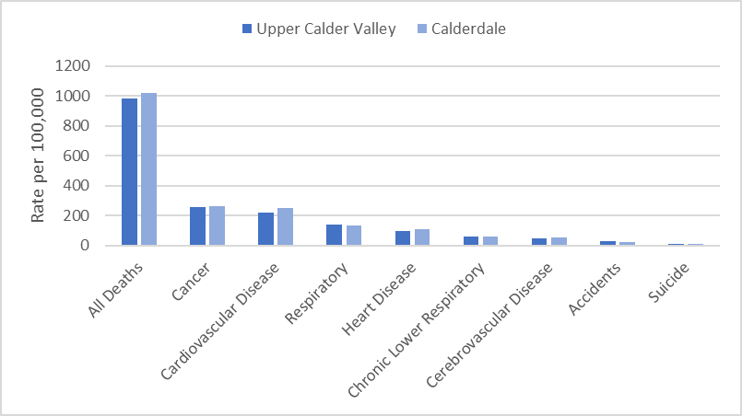
The directly standardised mortality rate (DSR) takes into account the age structure of the population and shows if the number of deaths per population is higher or lower compared to area averages.
Mortality in Upper was slightly lower than Calderdale for its age profile for all causes; but is significantly lower for those aged 65 & under and 75 & under. It is significantly lower for cardiovascular disease and heart disease for all ages and under 65s.
Ageing well
Pension credit is extra money given to those who are over state pension age and on a low income, to help with living costs. There is a slightly lower percentage of those aged 65+ in Upper claiming pension credit, (10.3% compared to Calderdale 11.0%)
Personal independence payment (PIP) is given to those with a long-term physical or mental health condition or disability who have difficulty doing certain everyday tasks or getting around. Attendance Allowance helps with extra costs if a person has a disability severe enough that they need someone to help look after them. There is a significantly lower proportion of residents in Upper aged 60+ claiming Personal Independence Payment; 1 in 14 in when compared to 1 in 12 for Calderdale. The proportion claiming Attendance Allowance is similar to Calderdale with around 1 in 11 residents claiming.
Mortality figures in those aged 65+ are not significantly different to the Calderdale average, apart from for accidents, which is significantly higher than Calderdale average, and dementia which is significantly lower than Calderdale.
Public Health CMBC
September 2023 V2

Red is significantly worse than Calderdale  Green is significantly better than Calderdale  Blue is significantly different to Calderdale  Calderdale rated compared to England average  INDICATOR | Upper | Calderdale | England | Source
Population Characteristics
Population
Total registered population | 34791 | 213519 |  | GP Practice Populations 2022
Registered population 0-4 | 1423 | 10604 |  | GP Practice Populations 2022
Registered population 5-14 | 3878 | 26441 |  | GP Practice Populations 2022
Registered population 0-19 | 7183 | 49414 |  | GP Practice Populations 2022
Registered population aged 65 and over | 7267 | 40039 |  | GP Practice Populations 2022
Registered population aged 75 and over | 3032 | 18128 |  | GP Practice Populations 2022
Registered population aged 85 and over | 757 | 4672 |  | GP Practice Populations 2022
Ethnicity
Percentage of the population who are Irish | 1.0 | 0.8 | 0.9 | 2021 census
Percentage of the population who are Gypsy/Irish Travellers/Roma | 0.1 | 0.2 | 0.1 | 2021 census
Percentage of the population who are White Other | 2.5 | 2.4 | 6.4 | 2021 census
Percentage of the population who are Asian | 2.3 | 10.5 | 9.6 | 2021 census
Percentage of the population who are Black | 0.4 | 0.7 | 4.2 | 2021 census
Percentage of the population who are Mixed Race | 2.1 | 2.0 | 3.0 | 2021 census
Percentage of the population who are "other" | 0.3 | 0.7 | 2.2 | 2021 census
Percentage of primary school children attending Calderdale schools who are Asian | 3.7 | 17.8 | 12.8 | Jan 2023 School Census
Percentage of secondary school children attending Calderdale schools who are Asian | 3.2 | 17.7 | 12.9 | Jan 2023 School Census
Religion
Percentage of the population who are Christian | 37.6 | 41.5 | 46.3 | 2021 census
Percentage of the population who are Buddhist | 0.6 | 0.3 | 0.5 | 2021 census
Percentage of the population who are Hindu | 0.1 | 0.6 | 1.8 | 2021 census
Percentage of the population who are Jewish | 0.1 | 0.1 | 0.5 | 2021 census
Percentage of the population who are Muslim | 2.0 | 9.5 | 6.7 | 2021 census
Percentage of the population who are Sikh | 0.1 | 0.2 | 0.9 | 2021 census
Language
Percentage main language is not English and cannot speak English well or at all | 0.3 | 1.4 | 1.8 | 2021 census
Sexual Orientation
Percentage of 16+ residents who identify as LGBTQ+ | 6.3 | 3.2 | 3.2 | 2021 census
Wider determinants of health
Percentage of households claiming council tax reduction | 13.8 | 16.8 |  | Calderdale Council Tax system c/o Calderdale Council Qlikview, accessed April 2023
Percentage of households claiming housing benefit | 7.0 | 7.8 | 8.8 | DWP - Housing Benefit claimants February 2023; stat-xplore.dwp.gov.uk, accessed 30 May 2023; Census 2021 Number of households by LSOA
Percentage of households claiming universal credit | 15.3 | 20.9 | 16.6 | DWP - Households claiming universal credit February 2023; stat-xplore.dwp.gov.uk, accessed 31 May 2023; Census 2021 Number of households by LSOA
Percentage of primary school children eligible for free school meals | 22.6 | 26.8 | 24.0 | Jan 2023 School Census
Percentage of secondary school children eligible for free school meals | 19.4 | 26.1 | 22.7 | Jan 2023 School Census
Percentage of households that are owned outright | 38.3 | 34.6 | 32.5 | 2021 census
Percentage of households that are owner occupied - Mortgage/Loan | 30.3 | 30.4 | 29.8 | 2021 census
Percentage of households rented from a social landlord | 12.1 | 14.5 | 17.1 | 2021 census
Percentage of households rented privately | 19.2 | 20.4 | 20.5 | 2021 census
Percentage of households without central heating | 2.3 | 2.1 | 1.5 | 2021 census
Percentage of households with no car or van | 22.2 | 24.5 | 23.5 | 2021 Census
Starting Well
Fertility rate per 1000 women aged 15-44 [2017-2021] | 52.3 | 60.1 | 59.2 | ONS, calculated by CMBC
Live birth rate per 1000 women aged 15-44 [2017-2021] | 52.0 | 59.9 |  | ONS, calculated by CMBC
Still birth rate per 1000 births [2017-2021] | 4.1 | 3.8 |  | ONS, calculated by CMBC
Percentage of low birth weight babies [2017-2021] | 6.1 | 7.0 | 6.8 | ONS, calculated by CMBC, figure differ from national as includes all gestations
Infant mortality rate per 1000 live births [2017-2021] | - | 4.3 | 3.9 | ONS, calculated by CMBC
Percentage smoking at delivery (2022/23) | 6.5 | 10.0 |  | Maternity system, calculated by CMBC
Percentage breastfeeding at delivery (2022/23) | 62.3 | 60.3 | 71.7 | Maternity system, calculated by CMBC
Percentage breastfeeding at discharge (2022/23) | 61.9 | 59.4 |  | Maternity system, calculated by CMBC
Percentage breastfeeding at 6-8 weeks (2022/23) | 58.3 | 51.6 | 49.2 | Maternity system, calculated by CMBC
Percentage of households with dependent children | 24.9 | 28.3 | 28.4 | 2021 Census
Developing well
Percentage of those aged under 18 claiming disability living allowance (November 2022) | 3.9 | 4.7 | 4.8 | Stat-xplore DWP, GP practice populations 2022
Excess weight reception age children [2019/22] | 14.9 | 17.4 | 22.6 | NCMP
Excess weight year 6 children [2019/22] | 28.6 | 34.3 | 35.8 | NCMP
Rate per 1000 population aged 0 to 17 referred to children's social care (2023) | 39.3 | 55.4 |  | CMBC Cass system accessed 30 May 2023; Census 2021
Children on a child protection plan (rate per 1000) 31 March 2023 | 2.0 | 5.1 |  | CMBC Cass system accessed 30 May 2023; Census 2021
Living and working well
Estimated smoking prevalence QOF (15+) [2021/22] | 16.7 | 17.5 | 15.4 | QOF
Obesity QOF Prevalence (18+) Patients with a BMI of 30 or above (2021/22) | 6.9 | 9.4 | 9.7 | QOF
Life Expectancy and All Cause Mortality
Life expectancy at birth in males [2019-2021] | 80.4 | 78.2 | 79.4 | ONS, calculated by CMBC
Life expectancy at birth in females [2019-2021] | 84.1 | 82.4 | 83.1 | ONS, calculated by CMBC
Directly Standardised Death Rate all causes (all ages) [2017 -2021] | 980.6 | 1017.9 |  | ONS, calculated by CMBC
Directly Standardised Death Rate all causes (aged <65) [2019 -2021] | 158.8 | 191.6 |  | ONS, calculated by CMBC
Long term conditions
Percentage of population with a long term health problem or disability which limits activities | 19.4 | 18.3 | 17.3 | 2021 census
Percentage of population who stated they were in good or very good health | 80.7 | 80.8 | 82.2 | 2021 census
Rate per 1000 population aged 18+ referred to adults social care (2021/22) | 41.9 | 47.7 |  | CMBC
Circulatory Diseases
Coronary Heart Disease prevalence (all ages) [2021/22] | 3.1 | 3.5 | 3.0 | QOF
Heart Failure: QOF prevalence (all ages) [2021/22] | 0.9 | 0.9 | 1.0 | QOF
Heart failure w LVD prevalence (all ages) [2021/22] | 0.2 | 0.3 | 0.4 | QOF
Stroke prevalence (all ages) [2021/22] | 2.0 | 2.0 | 1.8 | QOF
Atrial fibrillation: QOF prevalence (all ages) (2021/22) | 2.3 | 2.1 | 2.1 | QOF
Peripheral arterial disease QOF prevalence (all ages) [2021/22] | 0.7 | 0.8 | 0.6 | QOF
Hypertension: QOF prevalence (all ages) [2021/22] | 13.6 | 13.9 | 14.0 | QOF
DSR Deaths for ischaemic heart disease (all ages) [2017 -2021] | 96.0 | 110.7 |  | ONS, calculated by CMBC
DSR Deaths for ischaemic heart disease (aged <65) [2017 -2021] | 10.5 | 20.0 |  | ONS, calculated by CMBC
DSR Deaths for cerebrovascular disease (all ages) [2017 -2021] | 46.0 | 53.9 |  | ONS, calculated by CMBC
DSR Deaths for cerebrovascular disease (aged <65) [2017 -2021] | 4.7 | 6.4 |  | ONS, calculated by CMBC
DSR Deaths for cardiovascular disease (all ages) [2017 -2021] | 221.8 | 249.3 |  | ONS, calculated by CMBC
DSR Deaths for cardiovascular disease (aged <65) [2017 -2021] | 25.8 | 38.7 |  | ONS, calculated by CMBC
Cancer
Cancer prevalence all ages [2021/22] | 4.0 | 3.5 | 3.3 | QOF
Persons eligible, 25-49, attending cervical screening within target period (3.5 year coverage, %) 2021/22 | 73.7 | 71.7 | 69.0 | QOF
Persons eligible, 50-64, attending cervical screening within target period (5.5 year coverage, %) 2021/22 | 74.6 | 76.9 | 76.1 | QOF
Persons eligible, 50-70, screened for breast cancer in last 36 months (3 year coverage, %) 2021/22 | 34.9 | 47.2 | 62.3 | QOF
Persons eligible, 60-74, screened for bowel cancer in last 30 months (2.5 year coverage, %) 2021/22 | 71.4 | 72.8 | 70.3 | QOF
Number of emergency admissions with cancer (per 100,000) [2021/22] | 512.0 | 475.0 | 514.0 | QOF
Palliative/supportive care: QOF prevalence (all ages) [2021/22] | 1.2 | 0.5 | 0.5 | QOF
DSR for cancer (all ages) [2017 -2021] | 255.2 | 263.6 |  | ONS, calculated by CMBC
DSR for cancer (aged <65) [2017 -2021] | 58.6 | 58.9 |  | ONS, calculated by CMBC
Mental Health
Mental Health: QOF prevalence (all ages) [2021/22] | 1.4 | 1.1 | 1.0 | QOF
Depression: QOF incidence (18+) - new diagnosis [2021/22] | 2.0 | 1.8 | 1.5 | QOF
Dementia: QOF prevalence (all ages) [2021/22] | 0.8 | 0.7 | 0.7 | QOF
DSR for suicide (all ages) [2017-2021] | 11.9 | 13.5 |  | ONS, calculated by CMBC
Respiratory Conditions
COPD: QOF prevalence (all ages) [2021/22] | 2.5 | 2.2 | 1.9 | QOF
Asthma: QOF prevalence (all ages (6+)) [2021/22] | 7.9 | 7.4 | 6.5 | QOF
DSR for respiratory conditions (all ages) [2017-2021] | 142.4 | 132.3 |  | ONS, calculated by CMBC
DSR for respiratory conditions (aged <65) [2017-2021] | 14.3 | 15.6 |  | ONS, calculated by CMBC
DSR for chronic lower respiratory conditions (all ages) [2017-2021] | 61.9 | 62.0 |  | ONS, calculated by CMBC
DSR for chronic lower respiratory conditions (aged <65) [2017-2021] | 7.5 | 8.0 |  | ONS, calculated by CMBC
Other
Learning disability: QOF prevalence [2021/22] | 0.6 | 0.7 | 0.5 | QOF
Chronic Kidney Disease: QOF prevalence (18+) [2021/22] | 3.5 | 3.6 | 4.0 | QOF
Diabetes: QOF prevalence (17+) [2021/22] | 6.4 | 7.8 | 7.3 | QOF
Epilepsy: QOF prevalence (18+) [2021/22] | 0.9 | 1.0 | 0.8 | QOF
Rheumatoid Arthritis: QOF prevalence (16+) [2021/22] | 0.9 | 0.8 | 0.8 | QOF
DSR for accidents (all ages) [2017-2021] | 30.2 | 25.7 |  | ONS, calculated by CMBC
DSR for accidents (aged <65) [2017-2021] | 11.7 | 16.4 |  | ONS, calculated by CMBC
Ageing Well
Percentage aged 60+ claiming Personal Independence Payment (Jan 2023) | 7.2 | 8.5 | 6.5 | Stat-xplore DWP, GP practice populations 2022
Percentage aged 65+ claiming Attendance Allowance (Jan 2023) | 10.9 | 11.4 | 12.0 | Stat-xplore DWP, GP practice populations 2022
Percentage aged 65+ claiming pension credit (Nov 2022) | 10.3 | 11.0 | 11.2 | Stat-xplore DWP, GP practice populations 2022
Osteoporosis: QOF prevalence (50+) [2021/22] | 0.6 | 0.6 | 0.8 | QOF
DSR Deaths for all causes (aged 65+) [2017-2021] | 4373.0 | 4429.2 |  | ONS, calculated by CMBC
DSR Deaths for accidents (aged 65+) [2017-2021] | 106.5 | 64.2 |  | ONS, calculated by CMBC
DSR Deaths from Dementia (aged 65+) [2017-2021] | 229.6 | 305.2 |  | ONS, calculated by CMBC
DSR Deaths for ischaemic heart disease (aged 65+) [2017-2021] | 448.9 | 485.1 |  | ONS, calculated by CMBC
DSR Deaths from cerebrovascular disease (aged 65+) [2017-2021] | 216.4 | 249.9 |  | ONS, calculated by CMBC
DSR Deaths from cardiovascular disease (aged 65+) [2017-2021] | 1031.0 | 1118.4 |  | ONS, calculated by CMBC
DSR Deaths for cancer (aged 65+) [2017-2021] | 1066.6 | 1108.7 |  | ONS, calculated by CMBC
DSR Deaths for respiratory disease (aged 65+) [2017-2021] | 671.2 | 613.6 |  | ONS, calculated by CMBC
DSR Deaths for chronic lower respiratory disease (aged 65+) [2017-2021] | 286.7 | 284.7 |  | ONS, calculated by CMBC

Please contact the Public Health Intelligence team at ph.intelligence@calderdale.gov.uk if you require this data in another format.

