Calderdale Cares Neighbourhood Profile – Central
Map of area
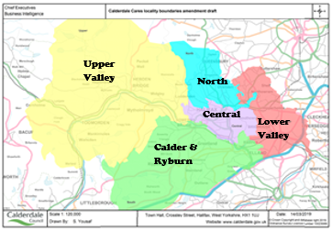
GPs in Central
Boulevard Medical Centre
King Cross Practice
Rosegarth Medical Practice Group
Spring Hall Medical Practice Group
Wards in Central: The wards do not map exactly to the neighbourhood boundaries; however, the following wards have part of their population living within Central; Park 83%, Skircoat 80%, Town 53%, Warley 56%

Population Characteristics
The total registered population of Central is 54,124, according to the 2022 GP Practice Populations.
Central has the largest ethnic minority population of the localities (43%), with Asian being the largest group, accounting for 34.6% of the population, followed by White Other (3.2%). Just over half of primary and secondary school pupils are Asian.
According to the 2021 Census around 4.2% of the population have stated that they cannot speak English well or at all which is higher than the Calderdale average.
Around a third of the population are Christian and a third are Muslim.
Figure 1 Population Pyramid
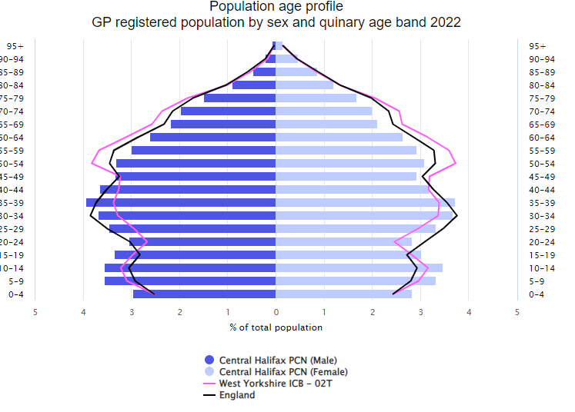
Source: GP Practice Populations 2022
The population pyramid shows that Central has a higher proportion of those aged between 0 to 44 when compared to Calderdale (Pink line – West Yorkshire ICB – 02T). There is a lower proportion of those aged 50 to 79 years when compared to Calderdale.
Wider determinants of Health
Central is a relatively deprived area with around 1 in 5 of its households claiming council tax reduction and over 1 in 4 claiming Universal credit. 25.9% of primary school children in the area are eligible for free school meals, which is similar to the Calderdale average. However, by secondary school this has increased to 29.5%, which is significantly higher than the Calderdale average.
Starting Well
The fertility rate in Central is significantly higher than the Calderdale average, with around 668 babies being born each year.
The proportion of women still smoking at the time of delivery is similar to the Calderdale average with 1 in 9 still smoking.
The percentage of babies born with a low birth weight (less than 2500g) is significantly higher than the Calderdale average. Approx. 53 babies in Central are born with a low birth weight each year.
59% of mothers breastfeed following delivery, remaining at a similar rate by the time mother and baby are discharged from hospital and 53.5% are still breastfeeding between 6 and 8 weeks post birth. These rates are similar to the Calderdale average.
Developing Well
Just under 1 in 3 households in Central have dependent children.
Excess weight for reception age children is slightly higher than the Calderdale average at around 19%, but not significantly. By year 6 it is significantly higher than the Calderdale average, with 38.8% having excess weight, the highest neighbourhood.
We do not have much information around the health conditions that children are living with, but we do know that the proportion claiming disability living allowance is similar to Calderdale’s average at 4.4%, compared to 4.7%.
Referrals to children’s social care are similar to the Calderdale average.
Living and Working Well
Smoking rates in Central are similar compared to Calderdale overall with just over1 in 6 estimated to be smokers.
Obesity prevalence amongst 18+ year patients with a BMI of 30 or above is significantly lower than the Calderdale average.
We currently do not have any other information around healthy lifestyles in adults at neighbourhood level.
Life Expectancy
Both Females and Males in Central have a life expectancy almost 1 year less than Calderdale average but this is not a statistically significant difference.
Long term conditions
According to the 2021 Census, 17.2% had a long-term health problem or disability which limits activities – this is significantly lower than the Calderdale average. We do not know how many of these had more than one long term condition.
There is a significantly higher referral rate to adults social care in adults aged 18 or over compared to the Calderdale average
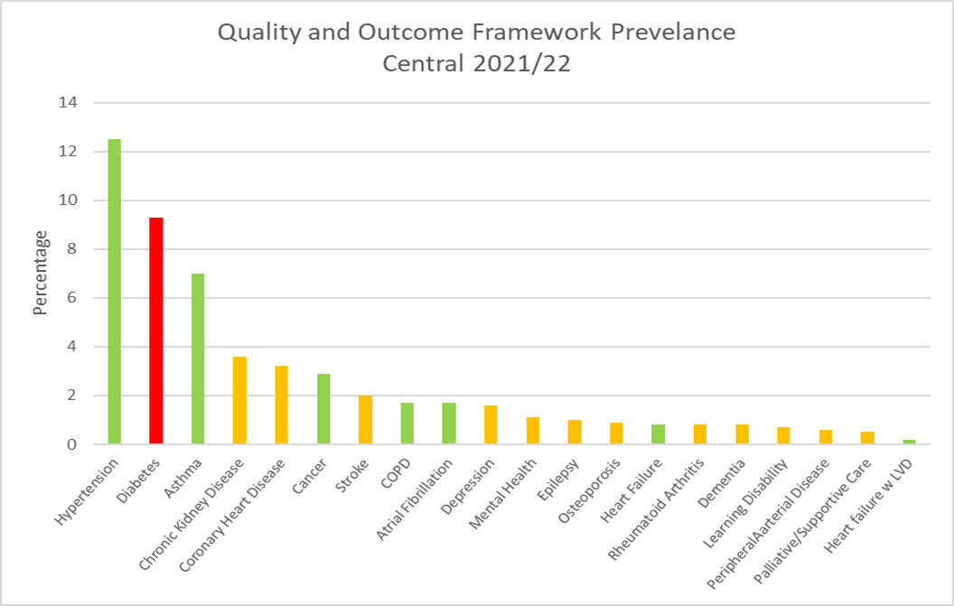
The graph shows the percentage of residents with each condition according to the Quality and Outcomes Framework (QOF). Bars coloured red are significantly higher than Calderdale, green is significantly lower, and amber is no significant difference. There are a few things to consider when interpreting this data:
- These rates do not take into account the age structure of the population so areas with a high percentage of older people are likely to have higher rates than the Calderdale average.
- Patients may have conditions that have not yet been diagnosed and therefore will not be included in the figures
- A high death rate will result in a lower prevalence
- There may be differences in coding and data quality that affect the figures
As can be seen from the graph, hypertension has the highest prevalence, followed by diabetes. We currently do not know how much clinical time is spent managing these conditions, the amount of medication used, and the costs associated with this. It could be that other conditions with a lower prevalence actually take up more clinical time and are more costly to manage.
It is useful to consider the incidence/prevalence of a condition as well as mortality rates, to get a better picture of need. However, it is important to bear in mind that the deaths have been adjusted to take into account the age structure of the population whereas the other data has not. Available data that we have for each condition is summarised over the page:
Circulatory Diseases
The percentages with hypertension and heart failure are significantly lower than the Calderdale average and the percentages with heart disease and stroke are similar to the Calderdale average. Deaths from cerebrovascular disease are significantly higher than the Calderdale average given the age structure of the population. Deaths from cardiovascular disease and heart disease are also significantly higher than Calderdale.
Cancer
Screening rates for cervical and bowel cancer are all significantly worse than the Calderdale average though the breast cancer screening rate is significantly better. The prevalence of any type of cancer is significantly lower than the Calderdale average and there is also a lower emergency admission rate for cancer. The rate of those receiving palliative/supportive care is similar to the Calderdale average.
The death rate from cancer is similar to Calderdale rate.
Mental Health
The percentage diagnosed with depression each year is similar to the Calderdale average, patients are only recorded as having depression if they receive medication, so if those not taking medication were included the numbers could be higher. The proportion living with mental health (schizophrenia, bipolar affective disorder, and other psychoses) is also similar to the Calderdale average.
The death rate from suicide is not significantly different to the overall Calderdale rate.
Respiratory Conditions
The percentages living with COPD and Asthma is significantly lower than Calderdale. Death rates from respiratory conditions are similar to the Calderdale average, apart from in those aged under 65, where it’s significantly worse.
Other
The proportion of people living with diabetes is significantly higher than the Calderdale average.
What do people die from?
On average, around 522 of Central’s residents die each year. Around 120 people die per year from cancer, and a similar number from cardiovascular disease, 67 from respiratory conditions, 50 from ischaemic heart disease and 31 from cerebrovascular disease.

Figure 2 Directly Standardised Mortality Rates for Leading Causes of Death 2017-2021
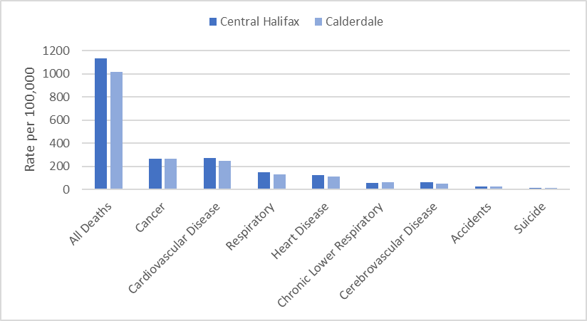
The directly standardised mortality rate (DSR) takes into account the age structure of the population and shows if the number of deaths per population is higher or lower compared to area averages.
Mortality in Central was significantly higher than Calderdale for all deaths for all ages, this is also the case for cerebrovascular disease, cardiovascular disease, and heart disease. Accidents, cancer, and respiratory conditions are higher than Calderdale, but this was not statistically significant.
Deaths from respiratory, cardiovascular and heart disease for those aged less than 65 were significantly higher than Calderdale.
Ageing well
Pension credit is extra money given to those who are over state pension age and on a low income, to help with living costs. Older people living in Central appear to be relatively more deprived than the Calderdale average. A significantly higher percentage aged 65+ claim pension credit, with 13.3% in Central compared to 11% for Calderdale.
Personal independence payment (PIP) is given to those with a long-term physical or mental health condition or disability who have difficulty doing certain everyday tasks or getting around. Attendance Allowance helps with extra costs if a person has a disability severe enough that they need someone to help look after them. Central has a significantly higher proportion compared to Calderdale claiming PIP (around 1 in 10) or Attendance Allowance at 65+ (around 1 in 8).
The death rate for all causes and dementia in those aged 65+ is significantly higher than the Calderdale average.
Public Health, CMBC September 2023
V2
Red is significantly worse than Calderdale  Green is significantly better than Calderdale  Blue is significantly different to Calderdale  Calderdale rated compared to England average  INDICATOR | Central | Calderdale | England | Source
Population Characteristics
Population
Total registered population | 54124 | 213519 |  | GP Practice Populations 2022
Registered population 0-4 | 3119 | 10604 |  | GP Practice Populations 2022
Registered population 5-14 | 7504 | 26441 |  | GP Practice Populations 2022
Registered population 0-19 | 14062 | 49414 |  | GP Practice Populations 2022
Registered population aged 65 and over | 8514 | 40039 |  | GP Practice Populations 2022
Registered population aged 75 and over | 4048 | 18128 |  | GP Practice Populations 2022
Registered population aged 85 and over | 1211 | 4672 |  | GP Practice Populations 2022
Ethnicity
Percentage of the population who are Irish | 0.5 | 0.8 | 0.9 | 2021 census
Percentage of the population who are Gypsy/Irish Travellers/Roma | 0.5 | 0.2 | 0.1 | 2021 census
Percentage of the population who are White Other | 3.2 | 2.4 | 6.4 | 2021 census
Percentage of the population who are Asian | 34.6 | 10.5 | 9.6 | 2021 census
Percentage of the population who are Black | 1.2 | 0.7 | 4.2 | 2021 census
Percentage of the population who are Mixed Race | 2.1 | 2.0 | 3.0 | 2021 census
Percentage of the population who are "other" | 1.8 | 0.7 | 2.2 | 2021 census
Percentage of primary school children attending Calderdale schools who are Asian | 51.3 | 17.8 | 12.8 | Jan 2023 School Census
Percentage of secondary school children attending Calderdale schools who are Asian | 52.2 | 17.7 | 12.9 | Jan 2023 School Census
Religion
Percentage of the population who are Christian | 32.1 | 41.5 | 46.3 | 2021 census
Percentage of the population who are Buddhist | 0.3 | 0.3 | 0.5 | 2021 census
Percentage of the population who are Hindu | 1.7 | 0.6 | 1.8 | 2021 census
Percentage of the population who are Jewish | 0.1 | 0.1 | 0.5 | 2021 census
Percentage of the population who are Muslim | 32.2 | 9.5 | 6.7 | 2021 census
Percentage of the population who are Sikh | 0.2 | 0.2 | 0.9 | 2021 census
Language
Percentage main language is not English and cannot speak English well or at all | 4.2 | 1.4 | 1.8 | 2021 census
Sexual Orientation
Percentage of 16+ residents who identify as LGBTQ+ | 2.3 | 3.2 | 3.2 | 2021 census
Wider determinants of health
Percentage of households claiming council tax reduction | 19.8 | 16.8 |  | Calderdale Council Tax system c/o Calderdale Council Qlikview, accessed April 2023
Percentage of households claiming housing benefit | 8.2 | 7.8 | 8.8 | DWP - Housing Benefit claimants February 2023; stat-xplore.dwp.gov.uk, accessed 30 May 2023; Census 2021 Number of households by LSOA
Percentage of households claiming universal credit | 27.3 | 20.9 | 16.6 | DWP - Households claiming universal credit February 2023; stat-xplore.dwp.gov.uk, accessed 31 May 2023; Census 2021 Number of households by LSOA
Percentage of primary school children eligible for free school meals | 25.9 | 26.8 | 24.0 | Jan 2023 School Census
Percentage of secondary school children eligible for free school meals | 29.5 | 26.1 | 22.7 | Jan 2023 School Census
Percentage of households that are owned outright | 33.1 | 34.6 | 32.5 | 2021 census
Percentage of households that are owner occupied - Mortgage/Loan | 28.9 | 30.4 | 29.8 | 2021 census
Percentage of households rented from a social landlord | 12.4 | 14.5 | 17.1 | 2021 census
Percentage of households rented privately | 25.5 | 20.4 | 20.5 | 2021 census
Percentage of households without central heating | 2.3 | 2.1 | 1.5 | 2021 census
Percentage of households with no car or van | 29.0 | 24.5 | 23.5 | 2021 Census
Starting Well
Fertility rate per 1000 women aged 15-44 [2017-2021] | 67.0 | 60.1 | 59.2 | ONS, calculated by CMBC
Live birth rate per 1000 women aged 15-44 [2017-2021] | 66.8 | 59.9 |  | ONS, calculated by CMBC
Still birth rate per 1000 births [2017-2021] | 3.6 | 3.8 |  | ONS, calculated by CMBC
Percentage of low birth weight babies [2017-2021] | 8.1 | 7.0 | 6.8 | ONS, calculated by CMBC, figure differ from national as includes all gestations
Infant mortality rate per 1000 live births [2017-2021] | 5.4 | 4.3 | 3.9 | ONS, calculated by CMBC
Percentage smoking at delivery (2022/23) | 11.4 | 10.0 |  | Maternity system, calculated by CMBC
Percentage breastfeeding at delivery (2022/23) | 59.3 | 60.3 | 71.7 | Maternity system, calculated by CMBC
Percentage breastfeeding at discharge (2022/23) | 58.5 | 59.4 |  | Maternity system, calculated by CMBC
Percentage breastfeeding at 6-8 weeks (2022/23) | 53.5 | 51.6 | 49.2 | Maternity system, calculated by CMBC
Percentage of households with dependent children | 32.0 | 28.3 | 28.4 | 2021 Census
Developing well
Percentage of those aged under 18 claiming disability living allowance (November 2022) | 4.4 | 4.7 | 4.8 | Stat-xplore DWP, GP practice populations 2022
Excess weight reception age children [2019/22] | 18.8 | 17.4 | 22.6 | NCMP
Excess weight year 6 children [2019/22] | 38.8 | 34.3 | 35.8 | NCMP
Rate per 1000 population aged 0 to 17 referred to children's social care (2023) | 54.5 | 55.4 |  | CMBC Cass system accessed 30 May 2023; Census 2021
Children on a child protection plan (rate per 1000) 31 March 2023 | 4.1 | 5.1 |  | CMBC Cass system accessed 30 May 2023; Census 2021
Living and working well
Estimated smoking prevalence QOF (15+) [2021/22] | 17.5 | 17.5 | 15.4 | QOF
Obesity QOF Prevalence (18+) Patients with a BMI of 30 or above (2021/22) | 8.3 | 9.4 | 9.7 | QOF
Life Expectancy and All Cause Mortality
Life expectancy at birth in males [2019-2021] | 77.2 | 78.2 | 79.4 | ONS, calculated by CMBC
Life expectancy at birth in females [2019-2021] | 81.6 | 82.4 | 83.1 | ONS, calculated by CMBC
Directly Standardised Death Rate all causes (all ages) [2017 -2021] | 1130.4 | 1017.9 |  | ONS, calculated by CMBC
Directly Standardised Death Rate all causes (aged <65) [2019 -2021] | 229.9 | 191.6 |  | ONS, calculated by CMBC
Long term conditions
Percentage of population with a long term health problem or disability which limits activities | 17.2 | 18.3 | 17.3 | 2021 census
Percentage of population who stated they were in good or very good health | 80.6 | 80.8 | 82.2 | 2021 census
Rate per 1000 population aged 18+ referred to adults social care (2021/22) | 52.6 | 47.7 |  | CMBC
Circulatory Diseases
Coronary Heart Disease prevalence (all ages) [2021/22] | 3.2 | 3.5 | 3.0 | QOF
Heart Failure: QOF prevalence (all ages) [2021/22] | 0.8 | 0.9 | 1.0 | QOF
Heart failure w LVD prevalence (all ages) [2021/22] | 0.2 | 0.3 | 0.4 | QOF
Stroke prevalence (all ages) [2021/22] | 2.0 | 2.0 | 1.8 | QOF
Atrial fibrillation: QOF prevalence (all ages) (2021/22) | 1.7 | 2.1 | 2.1 | QOF
Peripheral arterial disease QOF prevalence (all ages) [2021/22] | 0.6 | 0.8 | 0.6 | QOF
Hypertension: QOF prevalence (all ages) [2021/22] | 12.5 | 13.9 | 14.0 | QOF
DSR Deaths for ischaemic heart disease (all ages) [2017 -2021] | 126.6 | 110.7 |  | ONS, calculated by CMBC
DSR Deaths for ischaemic heart disease (aged <65) [2017 -2021] | 28.9 | 20.0 |  | ONS, calculated by CMBC
DSR Deaths for cerebrovascular disease (all ages) [2017 -2021] | 64.3 | 53.9 |  | ONS, calculated by CMBC
DSR Deaths for cerebrovascular disease (aged <65) [2017 -2021] | 8.3 | 6.4 |  | ONS, calculated by CMBC
DSR Deaths for cardiovascular disease (all ages) [2017 -2021] | 273.8 | 249.3 |  | ONS, calculated by CMBC
DSR Deaths for cardiovascular disease (aged <65) [2017 -2021] | 51.3 | 38.7 |  | ONS, calculated by CMBC
Cancer
Cancer prevalence all ages [2021/22] | 2.9 | 3.5 | 3.3 | QOF
Persons eligible, 25-49, attending cervical screening within target period (3.5 year coverage, %) 2021/22 | 60.3 | 71.7 | 69.0 | QOF
Persons eligible, 50-64, attending cervical screening within target period (5.5 year coverage, %) 2021/22 | 74.0 | 76.9 | 76.1 | QOF
Persons eligible, 50-70, screened for breast cancer in last 36 months (3 year coverage, %) 2021/22 | 59.8 | 47.2 | 62.3 | QOF
Persons eligible, 60-74, screened for bowel cancer in last 30 months (2.5 year coverage, %) 2021/22 | 69.2 | 72.8 | 70.3 | QOF
Number of emergency admissions with cancer (per 100,000) [2021/22] | 371.0 | 475.0 | 514.0 | QOF
Palliative/supportive care: QOF prevalence (all ages) [2021/22] | 0.5 | 0.5 | 0.5 | QOF
DSR for cancer (all ages) [2017 -2021] | 265.7 | 263.6 |  | ONS, calculated by CMBC
DSR for cancer (aged <65) [2017 -2021] | 60.9 | 58.9 |  | ONS, calculated by CMBC
Mental Health
Mental Health: QOF prevalence (all ages) [2021/22] | 1.1 | 1.1 | 1.0 | QOF
Depression: QOF incidence (18+) - new diagnosis [2021/22] | 1.6 | 1.8 | 1.5 | QOF
Dementia: QOF prevalence (all ages) [2021/22] | 0.8 | 0.7 | 0.7 | QOF
DSR for suicide (all ages) [2017-2021] | 11.5 | 13.5 |  | ONS, calculated by CMBC
Respiratory Conditions
COPD: QOF prevalence (all ages) [2021/22] | 1.7 | 2.2 | 1.9 | QOF
Asthma: QOF prevalence (all ages (6+)) [2021/22] | 7.0 | 7.4 | 6.5 | QOF
DSR for respiratory conditions (all ages) [2017-2021] | 147.4 | 132.3 |  | ONS, calculated by CMBC
DSR for respiratory conditions (aged <65) [2017-2021] | 22.7 | 15.6 |  | ONS, calculated by CMBC
DSR for chronic lower respiratory conditions (all ages) [2017-2021] | 59.4 | 62.0 |  | ONS, calculated by CMBC
DSR for chronic lower respiratory conditions (aged <65) [2017-2021] | 9.5 | 8.0 |  | ONS, calculated by CMBC
Other
Learning disability: QOF prevalence [2021/22] | 0.7 | 0.7 | 0.5 | QOF
Chronic Kidney Disease: QOF prevalence (18+) [2021/22] | 3.6 | 3.6 | 4.0 | QOF
Diabetes: QOF prevalence (17+) [2021/22] | 9.3 | 7.8 | 7.3 | QOF
Epilepsy: QOF prevalence (18+) [2021/22] | 1.0 | 1.0 | 0.8 | QOF
Rheumatoid Arthritis: QOF prevalence (16+) [2021/22] | 0.8 | 0.8 | 0.8 | QOF
DSR for accidents (all ages) [2017-2021] | 28.8 | 25.7 |  | ONS, calculated by CMBC
DSR for accidents (aged <65) [2017-2021] | 21.1 | 16.4 |  | ONS, calculated by CMBC
Ageing Well
Percentage aged 60+ claiming Personal Independence Payment (Jan 2023) | 10.0 | 8.5 | 6.5 | Stat-xplore DWP, GP practice populations 2022
Percentage aged 65+ claiming Attendance Allowance (Jan 2023) | 12.0 | 11.4 | 12.0 | Stat-xplore DWP, GP practice populations 2022
Percentage aged 65+ claiming pension credit (Nov 2022) | 13.3 | 11.0 | 11.2 | Stat-xplore DWP, GP practice populations 2022
Osteoporosis: QOF prevalence (50+) [2021/22] | 0.9 | 0.6 | 0.8 | QOF
DSR Deaths for all causes (aged 65+) [2017-2021] | 4848.0 | 4429.2 |  | ONS, calculated by CMBC
DSR Deaths for accidents (aged 65+) [2017-2021] | 60.7 | 64.2 |  | ONS, calculated by CMBC
DSR Deaths from Dementia (aged 65+) [2017-2021] | 406.1 | 305.2 |  | ONS, calculated by CMBC
DSR Deaths for ischaemic heart disease (aged 65+) [2017-2021] | 529.6 | 485.1 |  | ONS, calculated by CMBC
DSR Deaths from cerebrovascular disease (aged 65+) [2017-2021] | 295.5 | 249.9 |  | ONS, calculated by CMBC
DSR Deaths from cardiovascular disease (aged 65+) [2017-2021] | 1192.5 | 1118.4 |  | ONS, calculated by CMBC
DSR Deaths for cancer (aged 65+) [2017-2021] | 1111.2 | 1108.7 |  | ONS, calculated by CMBC
DSR Deaths for respiratory disease (aged 65+) [2017-2021] | 661.9 | 613.6 |  | ONS, calculated by CMBC
DSR Deaths for chronic lower respiratory disease (aged 65+) [2017-2021] | 265.3 | 284.7 |  | ONS, calculated by CMBC

Please contact the Public Health Intelligence team at ph.intelligence@calderdale.gov.uk if you require this data in another format.

