Calderdale Cares Neighbourhood Profile – Lower
Map of area
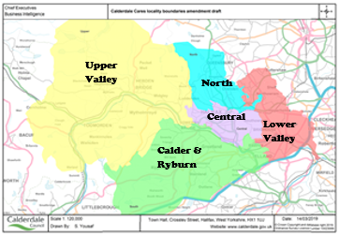
GPs in Lower
Church Lane Surgery
Longroyde Surgery
Rastrick Health Centre
Rydings Hall Surgery
The Northolme Practice (2 sites)
Wards in Lower: The wards do not map exactly to the neighbourhood boundaries; however the following wards have part of their population living within Lower; Brighouse 82%, Hipperholme and Lightcliffe 96%, Rastrick 99%, Northowram and Shelf 61%

Population Characteristics
The total registered population of Lower is 44,658, according to the 2022 GP Practice Populations.
There is a relatively small ethnic minority population (6.3%) with Asian and Mixed Race being the largest groups accounting for 2.1% and 1.9% of the population, respectively. Around 2.3% of primary and 2.3% of secondary school age children are Asian.
Around half the population state they are Christian, according to the 2021 Census.

Figure 1 Population Pyramid
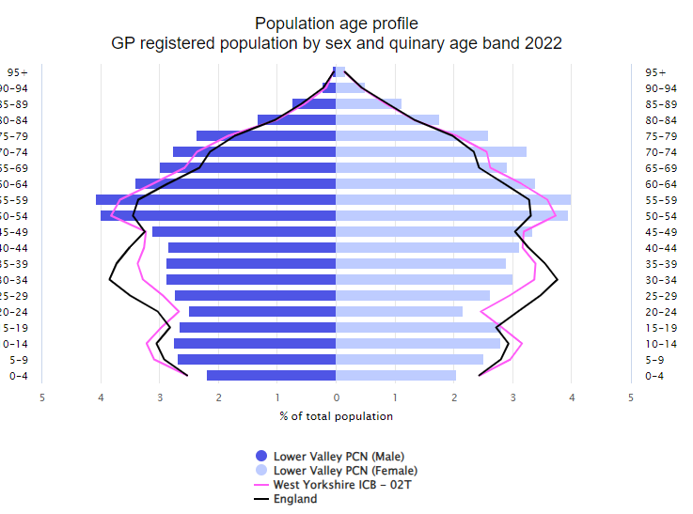
Source: GP Practice Populations 2022
The population pyramid shows that Lower has an older age profile compared to Calderdale overall (Pink line – West Yorkshire ICB – 02T). There is a lower proportion of the population who are aged between 0 to 49 when compared to both Calderdale and England and a higher proportion of the population who are aged 50+
Wider Determinants of Health
Lower appears to be the least deprived of the localities, with significantly lower levels of those claiming council tax reduction, housing benefit or universal credit. There are also significantly lower levels of primary and secondary school age children eligible for free school meals compared to the whole of Calderdale.
Around 1 in 5 households have no car or van which is also significantly lower than Calderdale (which is 1 in 4).

Starting Well
The fertility rate is significantly lower than the Calderdale average with around 411 babies being born each year.
The proportion of women still smoking at the time of delivery is significantly lower than the Calderdale average with around 1 in 15 still smoking.
The percentage of babies born with a low birth weight (less than 2500g) is significantly lower than for Calderdale overall. Approx. 22 babies in Lower are born with a low birth weight each year.
Breastfeeding rates at delivery and discharge from hospital are both significantly better than the Calderdale average with 68.6% of mothers breastfeeding following delivery and 68.3% by the time mother and baby are discharged from hospital. This drops to 54.7% still breastfeeding between 6 and 8 weeks post birth, but this is similar to the Calderdale average.
Infant mortality rates are significantly lower than the Calderdale average.
Developing Well
Just over 1 in 4 households in Lower have dependent children.
The percentage of children in reception with excess weight is similar to the Calderdale average, however the percentage of year 6 students with excess weight is significantly lower than Calderdale. Excess weight increases from 1 in 6 children in reception to 1 in 3 children by year 6.
We do not have much information around the health conditions that children are living with, but we do know that the proportion claiming disability living allowance is significantly lower than the Calderdale average at 3.4%, compared to 4.7%.
The referral rate to children’s social care was significantly lower than for Calderdale overall and there was a lower rate of children on a child protection plan.
Living and Working Well
Smoking rates are significantly lower than for Calderdale overall with around 13.4% of Lower’s residents estimated to be smokers.
The rate of obesity is significantly higher than the Calderdale average with 1 in 10 aged 18 or over recorded as having a body mass index of 30 or above.
We currently do not have any other information around healthy lifestyles in adults at neighbourhood level.
Life Expectancy
Both males and females in Lower are expected to live almost two years longer than the Calderdale average

Long term conditions
According to the 2021 Census, 17.6% had a long term health problem or disability which limits activities. This is significantly lower than the Calderdale rate of 18.3%. We do not know how many of these had more than one long term condition.
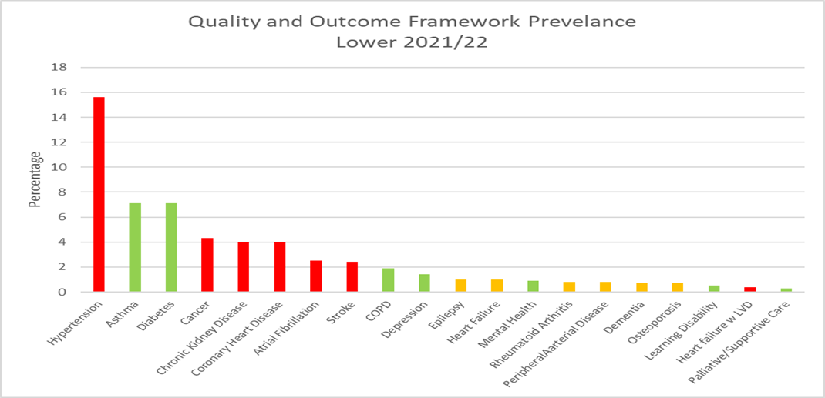
The graph above shows the percentage with each condition according to the Quality and Outcomes Framework (QOF). Bars coloured red are significantly higher than Calderdale, green is significantly lower and amber is not significantly different. There are a few things to consider when interpreting this data:
- These rates do not take into account the age structure of the population so areas with a high percentage of older people are likely to have higher rates than the Calderdale average.
- Patients may have conditions that have not yet been diagnosed and therefore will not be included in the figures
- A high death rate will result in a lower prevalence
- There may be differences in coding and data quality that affect the figures
As can be seen from the graph, hypertension has the highest prevalence, followed by asthma then diabetes. We currently do not know how much clinical time is spent managing these conditions, the amount of medication used and the costs associated with this. It could be that other conditions with a lower prevalence actually take up more clinical time and are more costly to manage.
It is useful to consider the incidence/prevalence of a condition as well as mortality rates, to get a better picture of need. However, it is important to bear in mind that the deaths have been adjusted to take into account the age structure of the population whereas the other data has not. Available data that we have for each condition is summarised on the next page:
Circulatory Diseases
The percentages living with coronary heart disease, hypertension, heart failure with LVD and stroke are significantly higher than the Calderdale average. Deaths from cardiovascular disease and heart disease for all ages and people aged 65+ is significantly lower than the Calderdale average.
Cancer
Screening rates for cervical, breast and bowel cancer are all significantly better than the Calderdale average. However, with between around 1 in 5 and 1 in 4 not attending screening, there is scope to increase these.
The percentage with any type of cancer is significantly higher than the Calderdale average as is the rate of emergency hospital admissions for cancer..
The death rates from cancer are similar to Calderdale.
Mental health
The percentage diagnosed with depression during 2021/22 is significantly lower than the Calderdale average. Patients are only recorded as having depression if they receive medication, so if those not taking medication were included the numbers could be higher. The proportion living with mental health (schizophrenia, bipolar affective disorder and other psychoses) is also significantly lower than Calderdale. The death rate from suicide is similar to the Calderdale rate.
Respiratory Conditions
The percentage of residents living with COPD or asthma is significantly lower than for Calderdale as a whole. The death rate from respiratory conditions is also significantly lower than Calderdale, given the age structure of the population.
Other
4.0% of the population are recorded as having chronic kidney disease which is significantly higher than the Calderdale average of 3.6%. The percentage living with diabetes is significantly lower than for Calderdale overall and the percentage living with epilepsy is the same as Calderdale percentage.
What do people die from?
On average, around 433 of Lower’s residents die each year. Around 129 people die per year from cancer, 107 from cardiovascular disease, 49 from respiratory conditions, 43 from ischaemic heart disease, 26 from chronic lower respiratory disease, 24 from cerebrovascular disease, and 6 residents die from suicide.
Figure 2 Standardised Mortality Ratios for Leading Causes of Death 2017-2021
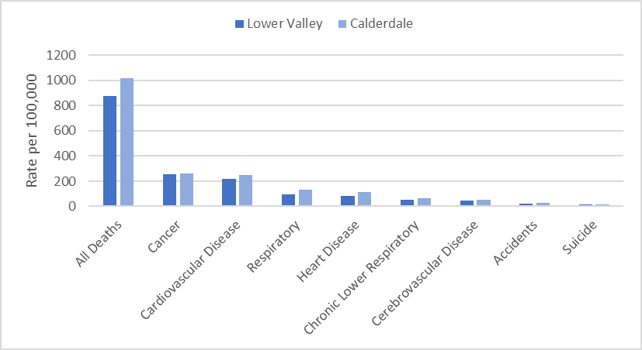
The directly standardised mortality rate (DSR) takes into account the age structure of the population and shows if the number of deaths per population is higher or lower compared to area averages.
Mortality in Lower was significantly lower than for Calderdale overall for all causes, ischemic heart disease (all ages and aged 65+), cardiovascular disease (all ages and aged 65+) and respiratory conditions (all ages, under 65 and 65+). None of the death rates were significantly higher.
Ageing Well
Pension credit is extra money given to those who are over state pension age and on a low income, to help with living costs. There are significantly lower levels of those aged 65+ claiming pension credit (7.7%) when compared to the Calderdale average (11%).
Personal independence payment (PIP) is given to those with a long-term physical or mental health condition or disability who have difficulty doing certain everyday tasks or getting around. Attendance Allowance helps with extra costs if a person has a disability severe enough that they need someone to help look after them. The percentage aged 60+ claiming Personal Independence Payment (6.7%) is significantly lower than for Calderdale (8.5%). The percentage of residents claiming Attendance Allowance is similar to Calderdale.
We do not have much information at neighbourhood level on the health of older people. However, we do know that the percentage living with osteoporosis is similar to the Calderdale average and that deaths in those aged 65+ from ischaemic heart disease, cardiovascular disease, dementia and respiratory disease are all significantly lower than Calderdale’s rate.

Public Health CMBC September 2023 V2

Red is significantly worse than Calderdale  Green is significantly better than Calderdale  Blue is significantly different to Calderdale  Calderdale rated compared to England average  INDICATOR | Lower | Calderdale | England | Source
Population Characteristics
Population
Total registered population | 44658 | 213519 |  | GP Practice Populations 2022
Registered population 0-4 | 1892 | 10604 |  | GP Practice Populations 2022
Registered population 5-14 | 4787 | 26441 |  | GP Practice Populations 2022
Registered population 0-19 | 9117 | 49414 |  | GP Practice Populations 2022
Registered population aged 65 and over | 10156 | 40039 |  | GP Practice Populations 2022
Registered population aged 75 and over | 4842 | 18128 |  | GP Practice Populations 2022
Registered population aged 85 and over | 1252 | 4672 |  | GP Practice Populations 2022
Ethnicity
Percentage of the population who are Irish | 0.8 | 0.8 | 0.9 | 2021 census
Percentage of the population who are Gypsy/Irish Travellers/Roma | 0.1 | 0.2 | 0.1 | 2021 census
Percentage of the population who are White Other | 1.3 | 2.4 | 6.4 | 2021 census
Percentage of the population who are Asian | 2.1 | 10.5 | 9.6 | 2021 census
Percentage of the population who are Black | 0.6 | 0.7 | 4.2 | 2021 census
Percentage of the population who are Mixed Race | 1.9 | 2.0 | 3.0 | 2021 census
Percentage of the population who are "other" | 0.3 | 0.7 | 2.2 | 2021 census
Percentage of primary school children attending Calderdale schools who are Asian | 2.3 | 17.8 | 12.8 | Jan 2023 School Census
Percentage of secondary school children attending Calderdale schools who are Asian | 2.3 | 17.7 | 12.9 | Jan 2023 School Census
Religion
Percentage of the population who are Christian | 50.2 | 41.5 | 46.3 | 2021 census
Percentage of the population who are Buddhist | 0.2 | 0.3 | 0.5 | 2021 census
Percentage of the population who are Hindu | 0.3 | 0.6 | 1.8 | 2021 census
Percentage of the population who are Jewish | 0.0 | 0.1 | 0.5 | 2021 census
Percentage of the population who are Muslim | 1.2 | 9.5 | 6.7 | 2021 census
Percentage of the population who are Sikh | 0.4 | 0.2 | 0.9 | 2021 census
Language
Percentage main language is not English and cannot speak English well or at all | 0.3 | 1.4 | 1.8 | 2021 census
Sexual Orientation
Percentage of 16+ residents who identify as LGBTQ+ | 2.5 | 3.2 | 3.2 | 2021 census
Wider determinants of health
Percentage of households claiming council tax reduction | 12.6 | 16.8 |  | Calderdale Council Tax system c/o Calderdale Council Qlikview, accessed April 2023
Percentage of households claiming housing benefit | 6.0 | 7.8 | 8.8 | DWP - Housing Benefit claimants February 2023; stat-xplore.dwp.gov.uk, accessed 30 May 2023; Census 2021 Number of households by LSOA
Percentage of households claiming universal credit | 13.9 | 20.9 | 16.6 | DWP - Households claiming universal credit February 2023; stat-xplore.dwp.gov.uk, accessed 31 May 2023; Census 2021 Number of households by LSOA
Percentage of primary school children eligible for free school meals | 17.8 | 26.8 | 24.0 | Jan 2023 School Census
Percentage of secondary school children eligible for free school meals | 17.0 | 26.1 | 22.7 | Jan 2023 School Census
Percentage of households that are owned outright | 39.6 | 34.6 | 32.5 | 2021 census
Percentage of households that are owner occupied - Mortage/Loan | 32.2 | 30.4 | 29.8 | 2021 census
Percentage of households rented from a social landlord | 11.6 | 14.5 | 17.1 | 2021 census
Percentage of households rented privately | 16.7 | 20.4 | 20.5 | 2021 census
Percentage of households without central heating | 1.7 | 2.1 | 1.5 | 2021 census
Percentage of households with no car or van | 19.7 | 24.5 | 23.5 | 2021 Census
Starting Well
Fertility rate per 1000 women aged 15-44 [2017-2021] | 54.6 | 60.1 | 59.2 | ONS, calculated by CMBC
Live birth rate per 1000 women aged 15-44 [2017-2021] | 54.3 | 59.9 |  | ONS, calculated by CMBC
Still birth rate per 1000 births [2017-2021] | 5.4 | 3.8 |  | ONS, calculated by CMBC
Percentage of low birth weight babies [2017-2021] | 5.5 | 7.0 | 6.8 | ONS, calculated by CMBC, figure differ from national as includes all gestations
Infant mortality rate per 1000 live births [2017-2021] | - | 4.3 | 3.9 | ONS, calculated by CMBC
Percentage smoking at delivery (2022/23) | 6.5 | 10.0 |  | Maternity system, calculated by CMBC
Percentage breastfeeding at delivery (2022/23) | 68.6 | 60.3 | 71.7 | Maternity system, calculated by CMBC
Percentage breastfeeding at discharge (2022/23) | 68.3 | 59.4 |  | Maternity system, calculated by CMBC
Percentage breastfeeding at 6-8 weeks (2022/23) | 54.7 | 51.6 | 49.2 | Maternity system, calculated by CMBC
Percentage of households with dependent children | 25.7 | 28.3 | 28.4 | 2021 Census
Developing well
Percentage of those aged under 18 claiming disability living allowance (November 2022) | 3.4 | 4.7 | 4.8 | Stat-xplore DWP, GP practice populations 2022
Excess weight reception age children [2019/22] | 15.6 | 17.4 | 22.6 | NCMP
Excess weight year 6 children [2019/22] | 29.9 | 34.3 | 35.8 | NCMP
Rate per 1000 population aged 0 to 17 referred to children's social care (2023) | 30.5 | 55.4 |  | CMBC Cass system accessed 30 May 2023; Census 2021
Children on a child protection plan (rate per 1000) 31 March 2023 | 2.6 | 5.1 |  | CMBC Cass system accessed 30 May 2023; Census 2021
Living and working well
Estimated smoking prevalence QOF (15+) [2021/22] | 13.4 | 17.5 | 15.4 | QOF
Obesity QOF Prevalence (18+) Patients with a BMI of 30 or above (2021/22) | 10.3 | 9.4 | 9.7 | QOF
Life Expectancy and All Cause Mortality
Life expectancy at birth in males [2019-2021] | 80.2 | 78.2 | 79.4 | ONS, calculated by CMBC
Life expectancy at birth in females [2019-2021] | 84.2 | 82.4 | 83.1 | ONS, calculated by CMBC
Directly Standardised Death Rate all causes (all ages) [2017 -2021] | 875.1 | 1017.9 |  | ONS, calculated by CMBC
Directly Standardised Death Rate all causes (aged <65) [2019 -2021] | 169.9 | 191.6 |  | ONS, calculated by CMBC
Long term conditions
Percentage of population with a long term health problem or disability which limits activities | 17.6 | 18.3 | 17.3 | 2021 census
Percentage of population who stated they were in good or very good health | 81.9 | 80.8 | 82.2 | 2021 census
Rate per 1000 population aged 18+ referred to adults social care (2021/22) | 41.0 | 47.7 |  | CMBC
Circulatory Diseases
Coronary Heart Disease prevalence (all ages) [2021/22] | 4.0 | 3.5 | 3.0 | QOF
Heart Failure: QOF prevalence (all ages) [2021/22] | 1.0 | 0.9 | 1.0 | QOF
Heart failure w LVD prevalence (all ages) [2021/22] | 0.4 | 0.3 | 0.4 | QOF
Stroke prevalence (all ages) [2021/22] | 2.4 | 2.0 | 1.8 | QOF
Atrial fibrillation: QOF prevalence (all ages) (2021/22) | 2.5 | 2.1 | 2.1 | QOF
Peripheral arterial disease QOF prevalence (all ages) [2021/22] | 0.8 | 0.8 | 0.6 | QOF
Hypertension: QOF prevalence (all ages) [2021/22] | 15.6 | 13.9 | 14.0 | QOF
DSR Deaths for ischaemic heart disease (all ages) [2017 -2021] | 85.6 | 110.7 |  | ONS, calculated by CMBC
DSR Deaths for ischaemic heart disease (aged <65) [2017 -2021] | 16.9 | 20.0 |  | ONS, calculated by CMBC
DSR Deaths for cerebrovascular disease (all ages) [2017 -2021] | 47.7 | 53.9 |  | ONS, calculated by CMBC
DSR Deaths for cerebrovascular disease (aged <65) [2017 -2021] | 6.7 | 6.4 |  | ONS, calculated by CMBC
DSR Deaths for cardiovascular disease (all ages) [2017 -2021] | 215.9 | 249.3 |  | ONS, calculated by CMBC
DSR Deaths for cardiovascular disease (aged <65) [2017 -2021] | 35.6 | 38.7 |  | ONS, calculated by CMBC
Cancer
Cancer prevalence all ages [2021/22] | 4.3 | 3.5 | 3.3 | QOF
Persons eligible, 25-49, attending cervical screening within target period (3.5 year coverage, %) 2021/22 | 79.5 | 71.7 | 69.0 | QOF
Persons eligible, 50-64, attending cervical screening within target period (5.5 year coverage, %) 2021/22 | 80.5 | 76.9 | 76.1 | QOF
Persons eligible, 50-70, screened for breast cancer in last 36 months (3 year coverage, %) 2021/22 | 70.3 | 47.2 | 62.3 | QOF
Persons eligible, 60-74, screened for bowel cancer in last 30 months (2.5 year coverage, %) 2021/22 | 77.9 | 72.8 | 70.3 | QOF
Number of emergency admissions with cancer (per 100,000) [2021/22] | 611.0 | 475.0 | 514.0 | QOF
Palliative/supportive care: QOF prevalence (all ages) [2021/22] | 0.3 | 0.5 | 0.5 | QOF
DSR for cancer (all ages) [2017 -2021] | 215.6 | 263.6 |  | ONS, calculated by CMBC
DSR for cancer (aged <65) [2017 -2021] | 57.8 | 58.9 |  | ONS, calculated by CMBC
Mental Health
Mental Health: QOF prevalence (all ages) [2021/22] | 0.9 | 1.1 | 1.0 | QOF
Depression: QOF incidence (18+) - new diagnosis [2021/22] | 1.4 | 1.8 | 1.5 | QOF
Dementia: QOF prevalence (all ages) [2021/22] | 0.7 | 0.7 | 0.7 | QOF
DSR for suicide (all ages) [2017-2021] | 14.5 | 13.5 |  | ONS, calculated by CMBC
Respiratory Conditions
COPD: QOF prevalence (all ages) [2021/22] | 1.9 | 2.2 | 1.9 | QOF
Asthma: QOF prevalence (all ages (6+)) [2021/22] | 7.1 | 7.4 | 6.5 | QOF
DSR for respiratory conditions (all ages) [2017-2021] | 98.2 | 132.3 |  | ONS, calculated by CMBC
DSR for respiratory conditions (aged <65) [2017-2021] | 9.5 | 15.6 |  | ONS, calculated by CMBC
DSR for chronic lower respiratory conditions (all ages) [2017-2021] | 51.3 | 62.0 |  | ONS, calculated by CMBC
DSR for chronic lower respiratory conditions (aged <65) [2017-2021] | 5.9 | 8.0 |  | ONS, calculated by CMBC
Other
Learning disability: QOF prevalence [2021/22] | 0.5 | 0.7 | 0.5 | QOF
Chronic Kidney Disease: QOF prevalence (18+) [2021/22] | 4.0 | 3.6 | 4.0 | QOF
Diabetes: QOF prevalence (17+) [2021/22] | 7.1 | 7.8 | 7.3 | QOF
Epilepsy: QOF prevalence (18+) [2021/22] | 1.0 | 1.0 | 0.8 | QOF
Rheumatoid Arthritis: QOF prevalence (16+) [2021/22] | 0.8 | 0.8 | 0.8 | QOF
DSR for accidents (all ages) [2017-2021] | 21.6 | 25.7 |  | ONS, calculated by CMBC
DSR for accidents (aged <65) [2017-2021] | 14.9 | 16.4 |  | ONS, calculated by CMBC
Ageing Well
Percentage aged 60+ claiming Personal Independence Payment (Jan 2023) | 6.7 | 8.5 | 6.5 | Stat-xplore DWP, GP practice populations 2022
Percentage aged 65+ claiming Attendance Allowance (Jan 2023) | 10.7 | 11.4 | 12.0 | Stat-xplore DWP, GP practice populations 2022
Percentage aged 65+ claiming pension credit (Nov 2022) | 7.7 | 11.0 | 11.2 | Stat-xplore DWP, GP practice populations 2022
Osteoporosis: QOF prevalence (50+) [2021/22] | 0.7 | 0.6 | 0.8 | QOF
DSR Deaths for all causes (aged 65+) [2017-2021] | 3786.6 | 4429.2 |  | ONS, calculated by CMBC
DSR Deaths for accidents (aged 65+) [2017-2021] | 49.5 | 64.2 |  | ONS, calculated by CMBC
DSR Deaths from Dementia (aged 65+) [2017-2021] | 223.6 | 305.2 |  | ONS, calculated by CMBC
DSR Deaths for ischaemic heart disease (aged 65+) [2017-2021] | 368.9 | 485.1 |  | ONS, calculated by CMBC
DSR Deaths from cerebrovascular disease (aged 65+) [2017-2021] | 217.2 | 249.9 |  | ONS, calculated by CMBC
DSR Deaths from cardiovascular disease (aged 65+) [2017-2021] | 960.0 | 1118.4 |  | ONS, calculated by CMBC
DSR Deaths for cancer (aged 65+) [2017-2021] | 1073.9 | 1108.7 |  | ONS, calculated by CMBC
DSR Deaths for respiratory disease (aged 65+) [2017-2021] | 464.4 | 613.6 |  | ONS, calculated by CMBC
DSR Deaths for chronic lower respiratory disease (aged 65+) [2017-2021] | 238.7 | 284.7 |  | ONS, calculated by CMBC

Please contact the Public Health Intelligence team at ph.intelligence@calderdale.gov.uk if you require this data in another format.

